Session 1

Overview of Christian Money Management
Matthew 6:19-24

¹⁹"Do not store up for yourselves treasures on earth, where moth and rust destroy, and where thieves break in and steal. ²⁰But store up for yourselves treasures in heaven, where moth and rust do not destroy, and where thieves do not break in and steal. ²¹For where your treasure is, there your heart will be also.
²²"The eye is the lamp of the body. If your eyes are good, your whole body will be full of light. ²³But if your eyes are bad, your whole body will be full of darkness. If then the light within you is darkness, how great is that darkness!
²⁴"No one can serve two masters. Either he will hate the one and love the other, or he will be devoted to the one and despise the other. You cannot serve both God and Money.
- Begin with a right perspective
  - Know the WHY before pursuing the WHAT and HOW.
  - Where are you NOW?
    - How many of you contribute to your company’s 401(k)? And those of you that are self-employed, how many of you contribute to an IRA? How many of you put in the maximum allow contribution? How many know what this is? How many know what your company matching rule is?
    - How many of you save at least 10% of your income? How many of you have at least 6 months worth of savings to live on at your current standard of living if you were to lose your job?
    - How many of you invest in mutual funds? Index funds? Stocks? Bonds? How many of you understand the principle of asset allocation?
    - How many of you have a financial planner? How many of you have consulted with different financial planners? How many of you read/study finances on your own? How many of you manage your own finances? Your spouse manages it?
    - How many of you spend from $2-5 per day on coffee, soft drinks, snacks, etc.? How many spend more?
    - How many of you – if you lose your job – would be pretty quickly in a really bad financial state?
  - Identify You Goals!
    - How many of you would like to retire early? How many of you have made plans to do it?
    - How many of you want to be a millionaire or beyond by the time you retire? How many of you have made plans to do it?
    - How many of you have dreams about your future? What are they?
  - What is money?
- Syllabus and A Quick Survey of Issues in Christian Money Management
  - Thinking rightly about money. Fundamental #1 – Living Below Your Means.
  - Before you start making money, you have to stop losing it. Fundamental #2 – Getting out of the Debt Cycle.
  - Thinking like the rich. Fundamental #3 – The Genius of Compounding Interest and the Rule of 72.
  - Behaving like the rich. Fundamental #4 – Automatic-pilot to Millions.
  - Becoming rich in a dangerous world. Fundamental #5 – Diversify everything.
  - Reality Check. Fundamental #6 – A True Balance with Real Goals.
  - Making Peace with Uncle Sam. Fundamental #7 – Planning with the IRS in mind.
  - True Wealth. Fundamental #8 – The Paradox of Giving.
  - Real Estate. Fundamental #9 – To Buy or Not to Buy.
  - Living well THEN by acting well NOW. Fundamental #10 – Steps toward great retirement living.
  - Preparing for Uncertainty. Fundamental #11 – Insurance A to Z.
- TEN REASONS for Financial Planning
  - Protect against EMERGENCIES
Injury, illness, death, lawsuits
  - Eliminate DEBT
    - You must move from owing money to owning money.
    - Total consumer debt in America (excluding mortgages) exceeds $1.4 trillion (cardweb.com). The average American holds 8 credit cards with an average balance of $8,400 per card.
    - You must make sure that you outlive your income, and that means you’ve got to accumulate assets so you can support yourself for a lifetime. That’s impossible to do if you have debts.
  - Prepare for LONG LIFE - Because you’re going to live a long, long time
    - At the time of the American Revolution, life expectancy at birth was 23 years. By 1900, Americans were expected to live only to age 47. Today the IRS, the NIH, and the CDC all say that a child born in 2004 has a life expectancy of 77 years, a 77-year-old today is expected to live to 88, and 88-year-old to 94 and people who reach 100 to 103.
    - How old will you be at 2100? Research suggests that people will live longer and longer. Most financial planners assume their clients will live to age 90, and conservative planners, to age 95. The longer you live, the more money you will need.
    - Based on new studies in gerontology, microbiology and biotechnology, some believer that by 2050 people could be expected to live to age 140.
    - During that time, many will have multiple marriages. Statistics show that 75% of all married Americans eventually find themselves single again – either through divorce or death of their spouse – and most people who were married once eventually remarry.
    - During that time, you may have five or six careers.
    - You’ll extend your rites of passage. In 1960, marrying in your teens was common; the phrase “old maid” applied to women who failed to marry by age 20. You were expected to have children before you were 25, we were told not to trust anyone over 30, middle age and mid-life crises hit at 45 and the “elderly” were 65. But today, most of my friends only recently got married and some are still waiting for that right one in their fifties. People are having children well into their late thirties and forties. If these trends continue, by 2050 people will be marrying (for the first time) at age 50, having kids in their 60s, facing middle age in their 80s, retiring in their 120s and dying in their 140s.
    - LONG-TERM CARE - Of those who reach age 65, according to the US Dept. of Health & Human Services and Americans for Long-term Care Security, 40% will spend time in a nursing home and 5% will require long-term care at some point. The average annual cost of a nursing home now exceeds $61,000; neither your health insurance nor Medicare will pay for it.
  - Pay for YOUNG CHILDREN
    - A 35-year old person earning $35,000 a month can earn $1,080,000 by the time he is 65. As much as this sounds, this will not be enough because of the enormity of expenses. One of the biggest ones is children.
    - According to the USDA, a baby born in 2001 will cost highest income families $337,690, middle income families $231,470 and lower income families $169,000, and that’s per child for only the first 17 years!
  - Pay for OLDER CHILDREN - College
    - When kids turn 18, they go to college. It’s estimated that for a baby born in 2002, the cost of college in 2020 will be $100,000 for an in-state school and $265,000 for private and out-of-state schools.
    - Considering the following
The Cost of a 4-year college degree
2002-2006
Penn State* | $106,521
Maryland* | $98,319
Berkeley* | $122,161
Notre Dame | $147,271
Harvard | $157,267
Georgetown | $158,116
Princeton | $166,060
Yale | $154,730
Assumes 6% annual increase in the cost of tuition, room and board – based on 2002-2003 prices.
* Out-of-state tuition
  - Pay for FEMALE CHILDREN - to pay for a daughter’s wedding
According to Conde Nast Bridal Group, the average cost is $22,360. Washington Magazine puts it at $28,000.
  - To buy a car
Average price of a new car is $26,670 according to the National Automobile Dealers Association.
  - To buy a home
  - Retire in STYLE - to be able to retire when – and in the Style – you want
    - Consider you and your spouse retire at 65 and life a normal life expectancy of 85, you’re going to eat 43,800 meals in retirement! (That’s 3 meals a day for 365 days a year over 20 years for two people.) If each meal cost five dollars, you’ll spend $219,000 on food. Where will that money come from?
    - Of today’s 65 and older 35% have incomes below $15,000 a year, according to the Social Security Administration. Only 15% of retirees earn more than $50,000 a year. Yet the masses didn’t plan to fail. They simply failed to plan, because under the old rules, planning wasn’t necessary.
    - If you fail to plan, you face the possibility of a retirement filled with poverty, welfare, and charity.
    - Interestingly a Gallup survey showed that 75% of workers want to retire before age 60, yet only 25% think they will.
  - Leave a FINANCIAL LEGAGY - to pass wealth to the next generation
    - Historically, money was passed from father to son. It started with our immigrant ancestors, who built homes and had children. When the children married, they moved into the house with Mom and Dad. Then the kids had kids, making it three generations in one house. As the family grew larger, each generation built new rooms, increasing the size – and the value – of the family’s wealth. When the first generation died, the second generation inherited the house, later passing it to the next generation, with each growing more affluent than the previous one.
    - That doesn’t happen today. We don’t have three generations living in one house as often as we once did. Today, when our grandparents die, we’re more likely to sell their house because we have our own home and we don’t need theirs. Furthermore, we find that our grandparents live so much longer than before – longer than they expected – that they often run out of assets and have nothing to leave to their children. Therefore, instead of passing wealth down to the children, the kids send money up to the parents. Thus, in many cases, the transfer of wealth is going backwards, and economists worry that most Americans are not prepared for this reality.
- The Four Obstacles to Building Wealth
  - Obstacle # 1: Procrastination – “I’ll do it later.”
Illustration: Jack and Jill
To understand this, consider the story of Jack and Jill. You know Jack fell down the hill, but you didn’t know that he suffered head injuries. As a result, Jack decided not to go to college. Instead, at age 18, he got a job, enabling him to contribute $4,000 to his IRA each year. After eight years, he stopped, having invested a total of $32,000.
Meanwhile, his sister Jill, inspired by Jack’s accident, went to medical school. At age 26, she began her practice and started contributing $4,000 to her IRA. And she did so for 40 years, from age 26 to 65. She invested a total of $160,000 and she put her money into the same investment as her brother Jack. Thus, Jill started investing the same year Jack stopped, and she saved for 40 years compared to just eight years for her brother.
By age 65, whose IRA account do you think was worth more money?
Assuming Jack and Jill each earned a 10% return, Jill accumulated $1,327,778, but Jack collected $1,552,739 -- $224,961 more than his sister!
While Jack had invested only $32,000 to Jill’s $160,000, his money earned interest for eight years longer than his sister. It wasn’t the money that made him successful – it was the time value of money. Jack didn’t procrastinate, and by investing sooner than Jill, his account grew larger.
    - It will be too late!
After all, who has time? You’ve got lots of deadlines and you don’t need another one. You’ve got to get to work on time, get your kids to soccer practice and prepare for out-of-town friends who will be visiting this weekend. With today’s deadlines, you don’t have time to work on something whose effects will not be felt for 20 years. But that’s okay because you’re still young and you’ll still have plenty of time later! Right?
Wrong!
Perhaps this is why so few people under 30 seek financial counsel. It just seems that young people don’t want to talk about something 40 years away: They’re more concerned about this weekend’s party!
I’ve heard a lot of excuses. If you’re in your 20s, you figure you’ve got 40 years to deal with it, so you’ll put it off until you are in your 30s…
…but by then, you’ve got a new house, new spouse, and new kids – and you’re spending money like never before. Who can think about saving at a time like this? You’ll deal with it later, after things settle down in your 40s.
…when indeed you’re making more money than ever, but now you find that your older children are entering college. On top of that, your income growth isn’t as rapid as it used to be. No problem, you say, because by the time you hit your 50s, you think your major expenses will be behind you…
…only to discover that your younger kids are entering college and the older ones are starting to get married (with you footing all these bills) and maybe the graduates need help buying a house, too. Your parents probably need some help as well, because they’re getting up in years. And you can’t remember the last time you got a promotion; after all, you’ve moved up so high in the company that the only way you’ll get promoted is for somebody to retire or die.
You’re finding that the cost of living has never been higher, so planning for retirement will just have to wait a bit longer…
…and when you hit 65, you lament your anemic savings and wish you had started 40 years ago.
This happens a lot.
If there is only one thing that you need to take on faith, it is this: There is never an ideal time for planning, and while you can always find a reason to put it off, don’t. Do it now. Procrastination will cause you financial ruin more effectively, more completely, than the worst advice a crooked broker could ever give you.
    - Waiting is Expensive! - The Cost of Procrastination
There is, in fact, a specific cost to procrastination. If you are 20 years old and you want to raise $100,000 by age 65, you need to invest only $1372 today (ignoring taxes for the moment and assuming a 10% annual return). But a 50-year-old would need to invest nearly $24,000 to obtain that same $100,000. This is the cost of procrastination. As you can see, it’s not money that makes people financially successful, it’s time.
Seen monthly, our 20-year-old would need to save less than $10/month, but the 50-year-old would need to save $239 a month.
Why $1,200 = $37,125
You may concede that starting young has its advantages. So, you think, I’m plenty young, so I can just start next year. After all, next year, I’ll still be young enough, but I’ll be making more money, and it’ll be easier for me to start. After all, what difference can one year make?
A big difference!
If a 30-year old saves $100 a month until age 65, earning 10% per year, the resulting account would be worth $379,664. BUT if this person waited just one year, beginning her savings at 31 instead of 30, her account at age 65 would be worth only $342,539. Thus, the cost of not saving $100 a month for just one year is $37,125. Can you really afford to blow thirty-seven grand?
Don’t procrastinate. Start now!
    - Boomerang Generation - Out the Door by Twenty-four
Situation #1
A man named Bob once called into a financial radio program. Age 23, he asked, “Ric, what should I do with my money? I have $24,000 and no debt.” I was impressed. Most of the 20-something I know are broke and have lots of credit cards. Bob said the bulk of his money was an inheritance and it was just sitting in his bank account.
The announcer asked him about his monthly expenses, expecting Bob’s reply to be in the range of $1,000 to $3,000; such an amount would be typical for folks in their 20s. Surprisingly, he said, “Oh, I spend about two hundred dollars a month.” Then the truth came out. Bob, 23 and a college graduate, lives at home.
Upon graduation, he became an official member of the Boomerang Generation. Mom and Dad shipped him of to college at age 18, paid the bill, and prepared to celebrate the fact that their child-rearing and child-supporting days were over.
But when Bob graduated, he didn’t move on with his life. Instead, he moved back. Bob once again lives with his parents, at their expense, and his total monthly spending of $200 goes to whatever he wants – parties, hanging out with friends, movies, eating out with the guys, weight-lifting at the club, and other activities of the financially secure.
Bob is able to participate in these avocations; of course, because “someone else” does his laundry, cooks his meals, and pays for the home he lives in.
Occupationally speaking, Bob is in a rut. Upon graduation, he missed the career track: Unable to get the job of his choice, he chose not to work at all. When asked, “When are you going to move out?” He said, “I’m in no hurry.”
I can see his point. Why should he move to a 700-square-foot, three-room apartment that costs $12,000 per month (plus utilities, Internet and telephone)? He’d have to buy furniture and a TV, drag his laundry to the Laundromat, shop for his own groceries, and cook his own meals.
Why should Bob do that, when he can live in a 3,000 square-foot, multi-level single family home on a quarter-acre lot in the suburbs, where somebody else takes care of his laundry, does the food shopping, and prepares dinner nightly?
Let’s face it, Bob’s got a great thing going here, and the operative initials are M-O-M. Bob can come and go as he pleases, has no bills to pay, and if something goes wrong, the landlord takes care of it, spelled D-A-D.
This is a matter of “growing up” and facing responsibilities. You are not doing ourselves any favors by remaining under your parents’ wings. If you live at home, you should pay rent, and at the very least, do house work for your keep.
Now, sometimes staying home makes financial sense – for those trying to save money. My problem is with those who live at home as freeloaders – and there is a big difference between the two.
Situation #2
For example, I read of one financially astute fellow named Mike. He is 26 and, like Bob, lives at his parents’ home. He didn’t go to college, but he’s been working since he was 16. Mom and Dad have always covered his expenses because Mike has always had a job and he contributes to running the household (doing chores, cooking, cleaning, and shopping). He’s diligent, conscientious, and – most important – Mike is good at saving money.
In fact, he is really good at saving money: Mike has $60,000, which he saved on his own – no gifts or inheritances. He’s accumulated his money throughout the 10 years he’s worked. And that’s why Mom and Dad have no problem with him living at home for free: They know that rather than forcing Mike to pay rent to them or some other landlord, he’s paying himself. So when he does decide to move out, he can afford to buy a place, not just rent it. Besides, like most suburbanites, Mom and Dad can afford to have Mike live in the house and they love to have him around, so it’s a great deal for everybody.
The Bobs of our nation won’t be 20-something forever and if they don’t learn to pay their way now, if they don’t start preparing to do so, they never will. If you are “Bob,” make up your mind today that you will begin to build your financial future. Don’t procrastinate any longer.
  - Obstacle #2: Spending Habits – Over-spending – “Where did it all go?”
Again, the problem is YOU, not the economy or world politics!
    - Situation
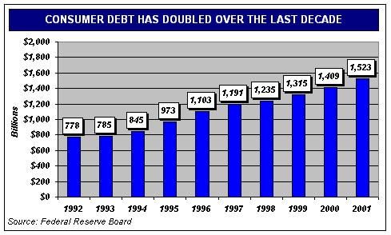
Consider the Newmans, married, with a combined annual income of $60,000. They felt they didn’t spend extravagantly, but they were nonetheless concerned that they couldn’t seem to save any money. “We don’t drive fancy cars or take big vacations and our kids don’t have the latest Reeboks,” they told me. “But we can’t seem to get ahead.”
Needless to say, the Newmans didn’t know where their money was going. After a little observation, this is what was discovered. The Newmans commuted to work separately. When they each got to the office, each would buy a newspaper for fifty cents, coffee ($1.25), and a doughnut ($1.00). In mid-afternoon break, they’d buy a candy bar ($.75). Without knowing the other was doing this, each was spending $3.50 a day, for a daily total of $7.00. With 20 working days per month, they were spending $140 per month, or $1,680 a year.
And guess what happens to the money you earn before you receive it? It gets taxed. In other words, the Newmans had to earn $2,400 in order to net the $1,680 that they frittered away on candy and soda. Yet, they claimed, “We can’t seem to save any money.”
    - Where Does My Money Go?
Have you ever withdrawn $50 from an automatic teller machine, yet find your wallet or purse empty just a few days later?
Have you ever asked yourself, “Where does all my money go?” Like the Newmans, you probably are piddling it away. You have no idea you’re doing it, because if you did know, you would stop instantly, for there isn’t a rational human being in the world who would tolerate such nonsense.
But we all piddle money away because we don’t pay attention. The Newmans were spending 3% of their annual income on… nothing! To avoid this problem, you’ve got to look at your spending habits, for that’s where you’ll find the key to your financial future.
  - Obstacle #3: Inflation – The Boiling Frog Syndrome
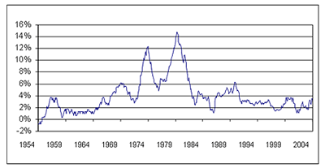
    - The Rules of Money have Changed
The most onerous of money’s enemies, inflation is perhaps the best illustration of how The Rules of Money Have Changed.
Over the past 25 years, inflation averaged 4.4% per year, according to Ibbotson Associates. At that rate, a 50-year-old earning $50,000 a year, who plans to retire at 65 on that same income, will need a net worth of $1.7 million – and his income in his first year of retirement needs to be $95,000.
In fact, 4.4% annual inflation means $1,000 will be worth less than two-thirds as much in 10 years. Put another way, you’ll need $1,538 in 10 years to buy what $1,000 buys today.
Perhaps too early for us to remember, on August 15, 1971 President Richard Nixon announced a 90-day wage and price freeze. Inflation was rampant and nobody could stop it – not Congress, the Federal Reserve Board, the President’s Council of Economic Advisors, the banks, or Wall Street. Nixon and the nation panicked. Convinced that inflation was going to cause an economic calamity worse than the Great Depression, the President stopped inflation artificially. For 90 days, nobody was permitted to raise salaries or prices. And the strategy worked – until the 91st day, anyway. When Pres. Nixon established his freeze in 1971, the inflation rate was just four percent. If that were the case 10 years later, Jimmy Carter would have been re-elected! By the time Jimmy Carter left office in 1980, inflation was 13% and banks were offering 15% CDs.
But you did not buy those CDs, because you were convinced that next month, CD rates would be 16% and you didn’t want to be stuck with “only” 15%! So you kept your money in daily accounts. You rode the interest wave up and right back down again!
Inflation – even very low inflation – once panicked our nation, but no longer. How can that be? The reason is the frog.
    - The Boiling Frog Syndrome
It is a familiar and true story. If you throw a frog into a pot of boiling water, he’ll jump out. But if you place a frog into a pot of lukewarm water and slowly turn up the heat, it will boil to death.
And so it is with inflation. We’ve grown accustomed to inflation over the past 25 years, but that doesn’t mean we don’t continue to be hurt by its effect. We are hurt even at “low” rates of inflation.

  - Obstacle #4: Taxes
We all love to hate taxes. According to the Tax Foundation, Tax Freedom Day is April 30 this year, meaning that every dollar you earn for the first four months of the year goes to taxes. Put another way, you work nearly three hours of each 8-hour workday just to pay taxes. No wonder we find it difficult to save money!
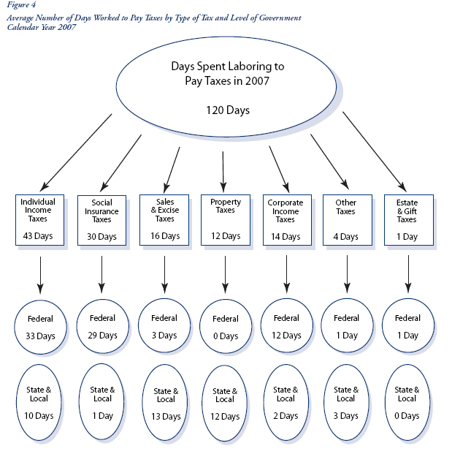
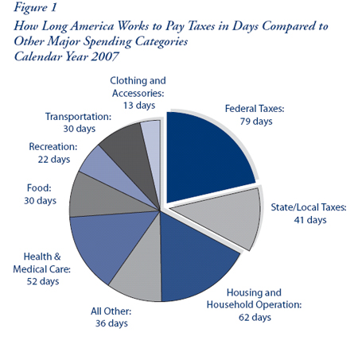
In addition to federal income taxes, you may also need to contend with state income taxes, property taxes, franchise taxes, sales taxes, user taxes, intangibles taxes, excise taxes, capital gains taxes, and estate taxes.
The amazing thing is that everybody thinks taxes are a natural part of life. Have we all forgotten why we revolted against England?
Our federal income tax wasn’t even created until 1913 – and it took a constitutional amendment to do it. And when the tax was established, it was quite low: There was no tax on the first $20,000 of income and only a 1% tax on income between $20,000 and $50,000 – and $20,000 was a lot of income in 1913!
You can guess what the politicians said back then, too. “Don’t worry,” I’ll bet they claimed, “tax rates will never rise!”
It’s the Boiling Frog Syndrome all over again.
- A Brief History Lesson - The Story of Taxes and Inflation
  - When everything was affordable.
Together, taxes and inflation create a web of incredible treachery, serving as another example of how The Rules of Money Have Changed.
At the turn of the century, taxes and inflation were not a concern. Homes cost $5,000 (Sears used to sell them from their catalog) and if you wanted to borrow money to buy your house, the bank charged you from 4% to 6%. If you deposited money into the bank, the bank paid you 2%; its profit was the difference between what it charged and what it paid.
Why was this generation willing to accept 2% return on their savings? Because it was profitable for them to do so: With no inflation, the 2% they earned was a real 2% and, with no taxes to pay, they got to keep it all. Thus, this generation was able to prosper from a 2% return on their money and banks were able to prosper by charging only 4% or 6% for their loans.
Banks were willing to offer 30-year-mortgages at these low rates because it had always been profitable to do so. Indeed, from 1879 to 1965, mortgage rates in the U.S. were very stable, consistently at 5.3% give or take half a point.
  - Then everything changed (1966).
But something happened in 1966. Rates began to rise and they’ve been fluctuating ever since.
Amazing! Interest rates that had remained constant since the end of the Civil War suddenly began to fluctuate, rocketing from 5.7% to 16.5% and crashing back down again.
Why did this happen? I don’t know. But it did. And as a result, banks got killed. In 1965, they gave borrowers 30-year, fixed-rate loans at 5.83%, but by 1980, they were paying 21% in CD rates. So, the banks found themselves earning 5.83% but paying out 21%. Yup, that’s a good way to kill a bank, and that’s why, in the 1980s, more banks failed than in any period since the Depression.
Bankers – some of the smartest economic minds in the nation – didn’t see inflation coming, so it’s no surprise that ordinary consumers didn’t, either.
  - What can we learn?
My point is that the past generations were able to succeed financially with a 2% bank account, yet, if we do what they did – if we handle our money the way they handled them – we will fail where they succeeded.
Here’s why: Assume CD rates are 2%. If you are in the 33% combined federal/state income tax bracket, you lose to taxes a third of everything you earn. Thus, if you earn 2%, you lose 0.66%, and keep only 1.34%.
But because of inflation, which is a little over 2%, you’re actually losing money.
This is why many people fail financially. They focus on how much they earn instead of how much they keep What counts is your after-tax, after-inflation rate of return. And that’s what we are going to focus on in this course. You’ve got to earn more than the current combined rate of inflation and taxes in order for your money to grow in real terms.
Some people complain today, “I can no longer get 6% or 8% CDs. Banks are not paying good rates any more.”
But the fact is that banks never paid “good rates.” It’s just that you’re noticing for the first time! You see, CD rates – like all interest rates – simply track inflation. When inflation rates are high, interest rates are high, and when inflation drops, interest rates drop. In 1980, for example, when interest rates were 15%, inflation was 13%.
Do the math: If you earned 15% on a CD, you netted 10% after taxes. But with 13% inflation, you were still losing in real terms. In other words, you were just as broke earning 15% in 1980 as you are earning 2% today. You simply never noticed. Now that you are thoroughly demoralized, let me assure you that there is a way out of this tax-and-inflation trap. We’ll talk about this next week ☺.
