- Introduction to the New Testament (11)
  - Why Study the New Testament?
    - The NT provides the fulfillment of the OT prophetic expectations.
    - The NT provides a absolute clarity to the way of salvation.
    - The NT provides the new rule of life for the people of God.
    - The NT further explains the future prophetic hope of the people of God.

  - A Comparison of the Two Testaments

Old Testament | New Testament
39 Books | 27 Books
929 Chapters | 260 Chapters
Covers over 4,000 years | Covers about 100 years
About 31 Authors | About 9 Authors

  - A Structural Outline of the New Testament for this Survey

I. The Gospels: The New Covenant Instituted
A. Matthew
B. Mark
C. Luke
D. John
II. The Acts: The New Covenant Proclaimed
III. The Epistles: The New Covenant Explained
A. The Pauline Epistles
1. Group 1: The Early Epistles
a. Galatians
b. 1 Thessalonians
c. 2 Thessalonians
2. Group 2: The Major Epistles
a. 1 Corinthians
b. 2 Corinthians
c. Romans
3. Group 3: The Prison Epistles
a. Ephesians
b. Colossians
c. Philemon
d. Philippians
4. Group 4: The Pastoral Epistles
a. 1 Timothy
b. Titus
c. 2 Timothy
B. The General Epistles
1. James
2. Hebrews
3. 1 Peter
4. 2 Peter
5. Jude
6. 1 John
7. 2 John
8. 3 John
IV. The Revelation: The New Covenant Fulfilled

- Overview of the New Testament (14)
  - Grand Theme of the New Testament

One of the overarching themes of the Bible is God’s plan to redeem mankind to a right relationship with Him. In the Old Testament God revealed that He would do this through His covenant promises, particularly the New Covenant (cf. Jeremiah 31:31-34). The New Covenant is one of three “sub-covenants” (Palestinian Covenant – Deut 30, Davidic Covenant – 2 Sam 7, and New Covenant – Jer 31) which further define and expand the original unconditional and eternal covenant God made with Abraham in Genesis 12:1-3 (cf. Gen 13:14-17; 15:1-21; 17:1-22; 22:15-18). The New Covenant primarily deals with salvation from sin. The NT teaches that the animal sacrifices of the OT could only cover (i.e. “atone for”) sin, but could never take away sin (cf. Heb 9:11-15, 24-28; 10:4-14). Only the blood of the God-man, Jesus Christ, could remove sin and set men free from the penalty and power of sin, so that they could fellowship with a holy God. Jesus’ death, therefore, was the basis of the New Covenant (cf. Luke 22:20). And while the New Covenant was originally given just to Jews, the NT reveals that because of the initial rejection by the Jews and the wideness of God’s grace, in this present “church age” the provisions of this covenant would extend to the Gentiles, making them partners in the New Covenant (cf. Gen 12:3; Eph 2:11-22; Rom 11:17; 2 Cor 3:1-18; Heb 8:8-13). Yet, in the future God will refocus on the Jews to fulfill His covenant promises to them (cf. Dan 9:24; Rom 11:25-27).

  - Structural and Historical Framework of the New Testament
The New Testament is divided into five sections: the Gospels (Matthew through John), history (the book of Acts), the Pauline Epistles (Romans through Philemon), the General Epistles (Hebrews through Jude), and prophecy (the book of Revelation). The New Testament was written from approximately A.D. 45 to approximately A.D. 95. The New Testament was written in Koine Greek (common Greek, the everyday form of the Greek language in the first century A.D.)
The Gospels give us four different, yet not conflicting, accounts of the birth, life, ministry, death, and resurrection of Jesus Christ. The Gospels demonstrate how Jesus was the promised Messiah of the Old Testament and lay the foundation for the teaching of the rest of the New Testament. The book of Acts records the deeds of Jesus' apostles, the men Jesus sent out into the world to proclaim the Gospel of salvation. Acts tells us of the beginning of the church and its rapid growth in the first century A.D. The Pauline Epistles, written by the Apostle Paul, are letters to specific churches - giving official Christian doctrine and the practice that should follow that doctrine. The General Epistles compliment the Pauline Epistles with additional teaching and application. The book of Revelation prophesies the events that will occur in the end times.

- Background to the New Testament (17)
  - God’s Covenants with Israel

  - The End of the OT

The Old Testament recorded the spiritual failures of the nation of Israel. Israel repeatedly violated the commands of God until God disciplined His people by sending them into captivity to Assyria and then to Babylon. After seventy years in Babylon, God allowed His people to return to their land and to function as a nation again. Men like Ezra, Nehemiah, Haggai, and Malachi were instrumental in this return and restoration. However, as the OT came to a close with the historical book of Nehemiah and the prophetic book of Malachi, the spiritual life of Israel once again began to deteriorate. God’s final word, through the prophet Malachi, was primarily a rebuke for Israel’s sinfulness. But included in that message was the promise that the Lord and His messenger would someday come (Mal. 3:1; 4:5-6). That promise would not be fulfilled for about four hundred years, when John the Baptist (the messenger) would announce the coming of the Lord Jesus Christ.

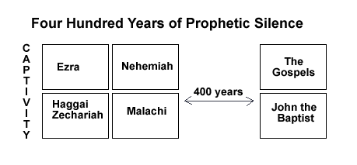

  - The Intertestamental Period
    - The Historical Background to the NT
      - The Persian Period (539-331 B.C.)

Independent Jewish state ended with the Babylonian invasion and captivity under Nebuchadnezzar in 605 B.C. Israel had a king but was a vassal of Babylon. In 586 the Jews revolted only to be put down and the city and temple destroyed. For fifty more years, Israel would be dominated by Babylon (cf. 2 Kings 24:1-25; 30; Jeremiah 39:1-8).

In 539 the Persians overthrew Babylon and became the new world power. Cyrus, the Persian king, in keeping with Isaiah’s prophecy (cf. Isaiah 45:13) allowed the Jews to return to their own land and rebuild their Temple in Jerusalem (cf. Ezra 1:1-4). With the encouragement of the prophets, Haggai and Zechariah, opposition and problems were overcome and the Temple was completed in 516 B.C. (cf. Ezra 1:5-6:22). Later, under the leadership of Ezra (458 B.C.) and Nehemiah (444 B.C.), others returned and built the walls of Jerusalem. Those leaders, aided by the prophet Malachi, attempted to bring about moral and spiritual reformation. Although they were not totally successful, they did succeed in elevating the Word of God to new heights of importance and led some in strictly applying the principles of the law to their everyday lives.

      - The Greek Period (331-143 B.C.)
        - Alexander the Great (331-323 B.C.)
Alexander the Great led his army to a swift and complete victory over the Persians. After defeating them, he swept into Palestine. The Jews did not resist Alexander and he, in turn, treated them well. Alexander’s conquest caused the rapid and extensive spread of Hellenism (Greek culture). The Greek language became the common trade and diplomatic language and by the NT times, it was the language of the common man (koine). This factor of a nearly universal language would have a significant impact on the rapid spread of the gospel of Jesus Christ.
With the early death of Alexander (33 yrs old, 323 B.C.), his vast army was divided into four parts. Because Alexander had no heir old enough to take his throne, four of his generals eventually partitioned the empire. Of the four, only two (Ptolemy and Seleucus) are significant for NT backgrounds. The empire of Ptolemy was centered in Egypt, while Seleucus’ empire centered in Syria.

        - The Ptolemies (321-198 B.C.)

The land of the Jews became part of Ptolemy’s empire at the division of Alexander’s empire. The Ptolemies controlled the Jews for more than a century. The Jews generally lived quiet and prosperous lives during this period, though periodic wars between the Ptolemies and the Seleucids turned Palestine into a war zone. Even so, both sides treated the Jews favorably to curry support for their side.

An important event occurred in the reign of Ptolemy Philadelphus (285-247 B.C.). He had the Hebrew OT translated by Jewish scholars into the Greek language so that the Jews born and raised in Alexandria under Greek culture might be able to read the Scriptures. This version, which is called the Septuagint (LXX), became a significant document to the Jewish community living outside of Palestine. Later, it was the Bible of the early church.
        - The Seleucids (198-143 B.C.)
Warfare and intrigue characterized much of the relationship that existed between the Ptolemies and the Seleucids. In 198 B.C. Antiochus III of Syria, with the help of a strong Jewish faction, defeated the Ptolemies and drove them back into Egypt. With the victory of Antiochus III, Hellenism swept the land of Palestine. The advancement of Hellenism continued under Antiochus IV (Epiphanes). Antiochus IV not only promoted Hellenism among the Jews, but he also attacked Jewish religion and culture.
So wicked was Antiochus IV that he is used in the Bible to picture the Antichrist, who will appear in the end times. The situation became intolerable to pious Jews, who were devoted to God’s law. A revolt started when a prominent priest, named Mattathias, from the town of Modein, defied a Syrian official who came to Modein to enforce pagan sacrifice. The courageous Mattathias not only refused to obey the king’s representative but also killed the Jew, who willingly stepped forward to carry out the sacrifice.
Mattathias then fled to the hills with his five sons and other pious Jews. Mattathias died shortly thereafter, but his son, Judas (known as “Maccabeus,” which means “the hammer”), took over the movement. The rebels achieved great success under Judas’ leadership. Initially, the Jews engaged in guerilla warfare, making it nearly impossible for the armies of Antiochus IV to subdue them. These victories were gained by Judas with greatly inferior forces, due to his strategy and his religious enthusiasm. Three years after Antiochus IV had desecrated the temple in Jerusalem, Judas and his forces soundly defeated the Syrians and were able to recapture Jerusalem and cleanse and rededicate the temple (December 165 B.C.). Finally, in 143 B.C., peace with the Syrians was achieved and the Jews had become independent of them.
      - The Hasmonean Period (143-63 B.C.)
Hasmonean is derived from the family name of Mattathias: Hashmon. Simon, a brother of Judas, was the first ruler of the independent Jewish state. He was declared to be both the civil leader and high priest of the Jews as long as he lived. This brought new power to the office of the high priest, which was felt in the days of Christ and the apostles. Simon’s reign was short but beneficial to the Jews. “A treaty was negotiated with Rome which was confirmed in 139 B.C., recognizing the independence of the Jewish state and commending it to the friendship of Rome’s subjects and allies. The economy improved, justice was ably meted out and Jewish religious life was revived. However, this was also a period of factious power struggles.
Simon and two of his sons were murdered , but another son, John Hyrcanus, became the political-religious ruler. Hyrcanus strengthened the Jewish state further. He was a capable military leader, defeating the Syrians, Samaritans, and Edomites. But not all of Hyrcanus’ actions welcome. For instance, he made an alliance with Rome, which was seen by the separatists (such as the emerging party of the Pharisees) as a compromise of faith and religious convictions. Also, Hyrcanus forced Judaism on the Idumeans, which was seen as a defilement of the Jews’ special covenant relationship with God. Also, many Jews refused to accept the priestly claims of the Hasmoneans, knowing that they were not descendants of Aaron. This internal strife came to a head in 63 B.C. The Roman army intervened in a civil war between two Hasmoneans. The army brought peace but also a new Roman domination.
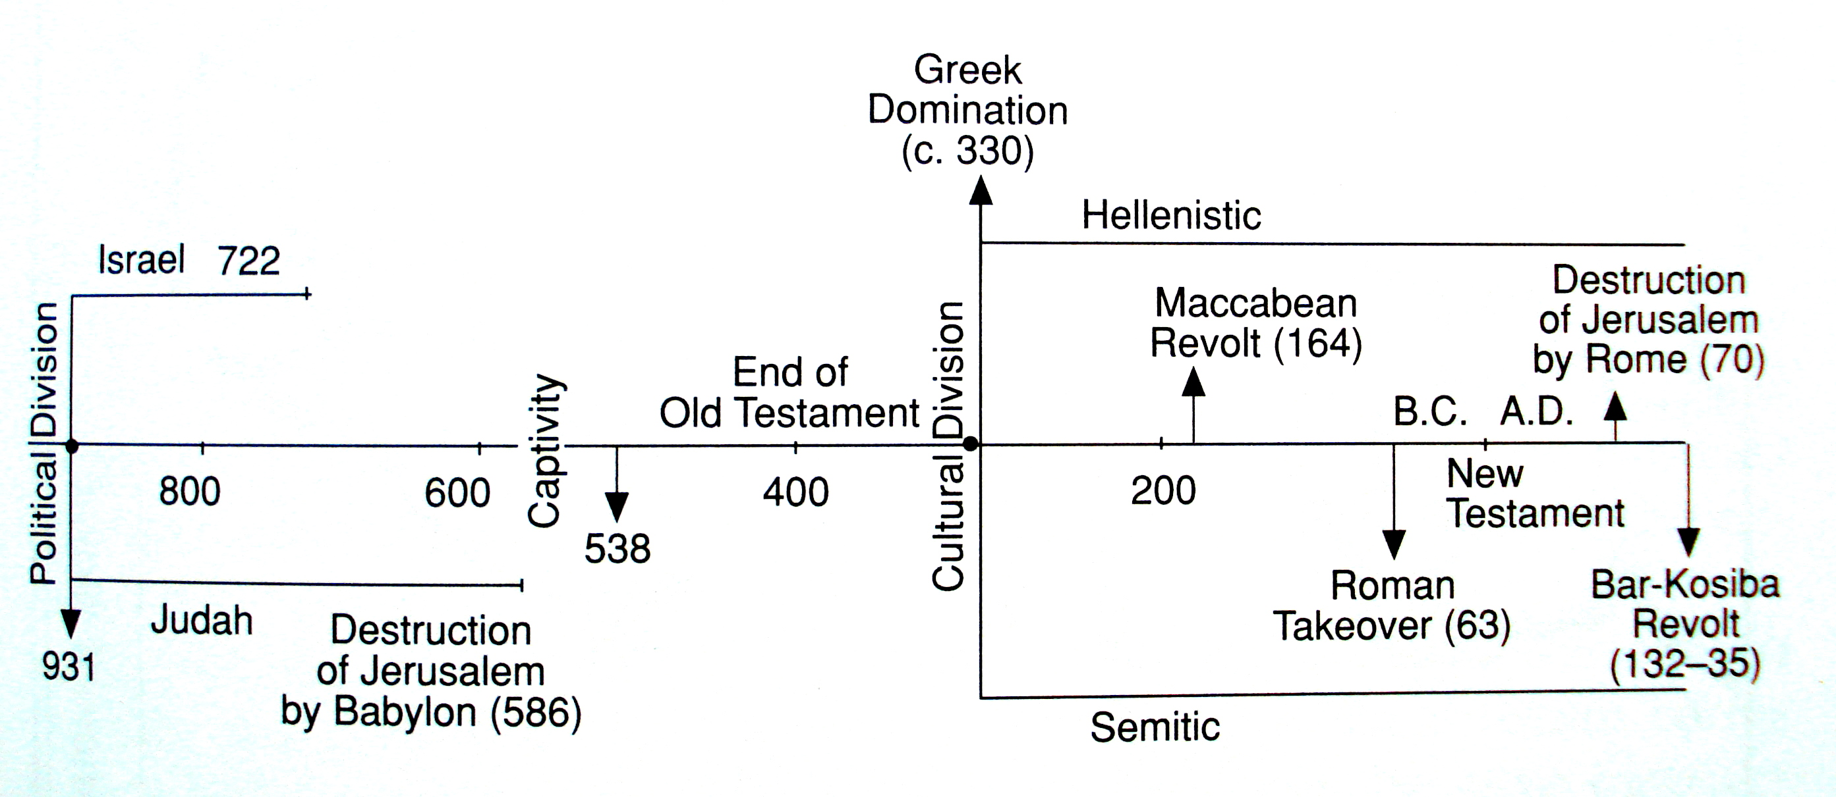

      - The Roman Period (63 B.C.-New Testament)
In 63 B.C. Rome set up John Hyrcanus II as king and also vassal of Rome. Even while Hyrcanus II rule, an Idumean named Antipater rose in favor with the Romans and was able to get two of his sons placed into positions of power in Palestine. One of his sons was Herod (the Great), who would eventually be declared king of Palestine. Herod ruled from 37 – 4 B.C. He was a man of great ability but also great wickedness (e.g. killed all the babies 2 and under in Bethlehem).

Person | Years Ruled | Territory | Relation to Herod | Scripture
Herod the Great | 37-4 B.C. | King of Palestine |  | Matt 2:1; Luke 1:5
Herod Antipas | 4 B.C. – A.D. 39 | Tetrarch of Galilee, Perea | Son | Luke 3:1; 13:31; 23:7
Archelaus | 4 B.C. – A.D. 6 | Ethnarch of Judea, Samraia, Idumea | Son | Matthew 2:22
Herod Phillip II | 4 B.C. – 34 A.C. | Tetrarch of Iturea, Trachonitis | Son | Luke 3:1
Herod Agrippa I | A.D. 37-44 | King of Palestine | Grandson | Act s 12:1-23
Herod Agrippa II | A.D. 48-70 | Tetrarchs of Chalcis, other territories | Great-grandson | Acts 25-26

    - The Religious Background of the NT
      - Religions and Philosophies in the Roman World
        - The Graeco-Roman Pantheon
The many Roman gods and goddesses of Rome were soon identified with the gods and goddesses of the Greek pantheon. For example, Venus, the Roman goddess of love, was also identified with the Greek goddess of love, Aphrodite; Diana was Artemis (cf. Acts 19); Mars was Ares (cf. Acts 17); Jupiter was Zeus, Mercury was Hermes (cf. Acts 14), and so on. But by the NT Times, the worship of the host of gods and goddesses was on the decline, and the mystery religions that emphasized personal and ecstatic experiences were on the rise. The power struggles, the intrigue, and the immorality of the gods, with their apparent inability to help the worshipers, accelerated this transition. The whole system of deities was challenged and scorned by many philosophers and teachers.

        - Emperor Worship
Long before Rome, nations had exalted their rulers as gods. In a polytheistic world, the imperial cult of Rome was not unique. Initially, emperors were deified after death, but in the 1st century A.D. some, like Nero, claimed deity while living. Needless to say, Christians suffered great persecution for their refusal to recognize the emperor as a god. To the Romans the issue was not simply religious but also patriotic.
        - The Mystery Religions
The mystery religions were experience-oriented religions, promising a mystical union with some deity for those initiates, who learned the secrets of that religion. In contrast to emperor worship and traditional religion, these religions offered a more personal, experiential faith to people and appealed to the emotions rather than to the will or to the intellect. Ecstatic experience rather than teaching was emphasized. (What teachings there were often were vague and highly symbolic). While there were different nuances to the mystery religions, they had a common element of divine union, which guaranteed immortality. The mysteries also featured secret initiatory and other rites involving ceremonial washing, blood sprinkling, sacramental means, intoxication, emotional frenzy, and impressive pageantry by which devotees came into union with deity. Social equality within the mysteries helped make them attractive.
        - Gnosticism
The name Gnosticism comes from the Greek work gnosis, which means “knowledge.” Salvation could be achieved by obtaining certain knowledge. This philosophy was based on Plato’s dualism, which taught that matter was evil and spirit was good. The Gnostics believed that God was too great to have a body and even the world as we know it was only created by a lesser God, or emanation from God.
Gnosticism spawned into two divergent applications in the practical lives of people. First, there was asceticism, or the severe suppression of the appetites and desires of the body. These people lived their lives with strict restrictions and controls on the desires of their “evil” body. A second application of this philosophy was libertinism. Believing that the material body to be evil and not subject to salvation, they lived indulging the desires and appetites of the body. Since on their spirit would be saved, what they did with the material body was irrelevant to ultimate reality – so they indulged.
Colossians and 1 John may have been written in part to refute this emerging philosophy.
        - Other Philosophies
Many other philosophies existed in NT times. Acts 17:21 reveals that philosophy was a passion of many people and that something “new” was always of great interest. Consider this summary by Robert Gundry:
The intelligentsia were turning to purer forms of philosophy. Epicureanism taught pleasure (not necessarily sensual) as the chief good in life. Stoicism taught dutiful acceptance of one’s fate as determined by an impersonal Reason which rules the universe and of which all men are a part. The Cynics, who have many counterparts, regarded the supreme virtue as simple and unconventional life in rejection of the popular pursuits of comfort, affluence, and social prestige. The Skeptics were relativists who abandoned belief in anything absolute and succumbed to doubt and conformity to prevailing custom. These and other philosophies, however, did not determine the lives of very many people. Generally, superstition and syncretism characterized the masses. Thus, Christianity entered a religiously and philosophically confused world… Gloom and despair prevailed.
      - Religion in Israel
        - The Pharisees
The name Pharisee comes from a Hebrew word that means “to separate,” and so the Pharisees were referred to as the separated ones. From the time of the Jews’ return from the Babylonian captivity through the Intertestamental period, a movement for purity for the things of the LORD grew. During the Intertestamental period, there came into existence in Judaism a movement that was determined to free Israel from Pagan influences. These “Hassidim,” or “pious ones,” were zealous for religious reform and known for their resistance to Hellenism. They were probably the foundation of the sect of the Pharisees. This separatist movement was given great momentum when the Syrian king Antiochus Epiphanes (175 B.C.) tried to force heathen practices on the Jewish people. From about 125 B.C. the distinct part of the Pharisees could be found in Jewish society.
The Pharisees believed strongly in a separation from the ways and the practices of the Gentiles. They had an unbending loyalty to the Scriptures and desired to live strictly by the law. But in their desire to make the law workable in everyday life, they developed a system of regulations and traditions, which by the time of Christ had become a terrible burden on the people. The Pharisees promoted these traditions to a place of equal or greater importance than the written law of Moses. They became proud of their separation and knowledge and viewed themselves as superior to the rest of society. Jesus would condemn their pride, self-righteousness, and violation of the spirit of the law. Nevertheless, it was their zeal for the Scriptures that kept the Messianic hope alive in the days of Roman rule.
There were about six thousand Pharisees in Jesus’ day. They were not very many; however, they wielded tremendous power in Israel because they had the support of the people. They were mainly composed of members of the middle class, through there were a few priests and Levites in their ranks as well. Most were merchants and tradesmen. Entrance into the ranks of the Pharisees was preceded by a period of probation, from one month to a year. During this time the personal piety and zeal of the candidate was observed. Tithing, fasting, and separation from uncleanness were basic matters to be observed.
The Pharisees met not only in the synagogues with the rest of the populace but also in communities. Each of these communities was headed by a scribe, who served as a professional authority in the matter of interpreting the law. In the communities, they studied the law and worshipped together (usually on the evening before the Sabbath). But it was in the synagogues that they exercised their greatest influence over the people.
        - The Scribes
The scribes were not a party as were the Pharisees but rather a class of Israelites. They were well-educated persons whose job it was to teach and interpret the law. They are also called “doctors of the law” and the “Lawyers” in the Gospels. They not only taught the law but were responsible to prosecute those who broke the law. (This is what Saul of Tarsus was doing when he was headed toward Damascus to persecute Christians.) A great majority of the scribes belonged to the party of the Pharisees. It should be noted that while most scribes were Pharisees, most Pharisees were not scribes. In the days of Christ, the scribes were the most influential members of the pharisaic party.
        - The Sadducees
The sect of the Sadducees originated during the Intertestamental period. The name Sadducee may have been derived from the name “Zadok,” who was the high priest in the days of David and Solomon. Another possibility is that the name might have come from the word zedekah, which means “righteousness.”
The Sadducees were less numerous than the Pharisees, but they were men who were generally wealthy and in places of political authority. The party of the Sadducees included high-ranking priests and the wealthy lay nobility. Close association with the priests can be traced back to the rule of John Hyrcanus. The Sadducees possessed a great deal of political power in the days of Rome. Because they had so much prestige, power, and wealth to lose, they were far more cooperative with Rome than were the Pharisees. As a sect, however, they ceased to exist after the destruction of the city of Jerusalem in A.D. 70.
As for their beliefs, they refused to accept the oral law developed by the Pharisees. They seem to have limited the full authority of Scripture to just the five books of Moses (Genesis – Deuteronomy). They did not believe in angels, demons, the resurrection, or a coming Messiah.
        - The Essenes
The Essenes may have originated during the Intertestamental period in the days of the Maccabees. Many scholars believe their roots, like those of the Pharisees, are to be traced back to the Hassidim. They lived in isolated communities in Judea, especially west of the Dead Sea in places like Qumran. It is believed there were about four thousand of them.
They were even more separated than the Pharisees, choosing not to live in Jewish society. They were known for their strict, rigid lifestyle. They are not mentioned by name in the NT, but some believe that John the Baptist may have had some contact with them.
        - The Herodians
The Herodians were more of a political party than a religious sect. They originated during the time of the Herodian dynasty and were supporters of that dynasty. They accepted Hellenization and were desirous of political power and worldly benefits that came to loyal supporters of Herod’s family. It could be that many of the Jews who collected taxes for Rome were Herodians. Normally the Herodians and the Pharisees were archenemies, but in the case of Christ they temporarily set aside their antagonism in order to unite against a common enemy (cf. Mark 3:6; 12:13).
        - The Zealots
Probably one of the most difficult groups to identify with great accuracy is the Zealots. It is clear, however, that there existed in first-century Palestine groups who advocated the violent overthrow of Rome (cf. Mark 15:7). They were absolutely intolerant of Roman presence (or anything Gentile) in Palestine. Some believe the Zealots began when Judas the Galilean led a revolt against Rome in A.D. 6 (cf. Acts 5:37). The term zealot may have been a general designation of those that believed that God alone was their ruler and no lordship of man would be tolerated.
The term sicarii appears in Jewish literature. The word is of Latin of origin and has the idea of “assassins.” It was applied to a group of Jewish radicals who used a sica (a short sword) in their hit-and-run assassination of Romans and Roman sympathizers. They may or may not be related to the Zealots; however, their basic ideals were the same, namely, the removal of Rome from Palestine.
The Zealots were responsible for a number of revolts in the first century. It was their activity that brought about the terrible Roman wars of A.D. 66-72 in which Jerusalem was destroyed and tens of thousands of Jews were killed.
        - The Sanhedrin
The word Sanhedrin was derived from the Greek and given a Hebraic form. It literally means “sit together.” Fundamentally it has the idea of a council or a governing body and can also include the idea of a court. The Great Sanhedrin was the national council of Jews (something like the Jewish “supreme court”). It was made up of 71 members, the high priest being the president. The Sanhedrin met in Jerusalem in the confines of the temple. Although the idea of a representative council can be found in the time of Ezra, the Sanhedrin of the NT era traces its organization to about the time of John Hyrcanus (135 B.C.), the days of Jewish independence in the Intertestamental period.
There were numerous small sanhedrins, or councils, in the towns throughout Judea and Galilee, but these were limited in power and influence as they dealt strictly with local matters. The Great Sanhedrin, however, had great power and involved itself in both religious and civil matters. This power was limited, of course, by Roman domination. The Sanhedrin was stripped of a great deal of power, including that of capital punishment, in the days of Herod the Great. But the Romans did allow the Sanhedrin extensive authority in Jewish internal affairs.
It was the Great Sanhedrin that found itself in conflict with the Lord Jesus (John 9). Members attempted to arrest Him on several occasions (e.g. John 7:32); they desired to kill Him (Luke 22:2); they participated in His arrest (Mark 14:43); they broke their own laws and code of ethics in their trial of Him (e.g. Matt 26:59; 27:41); and they are held accountable by Scripture for their actions (Acts 2:23, 36; 3:13).
The Great Sanhedrin has several designations in the NT. It is sometimes called the “council” (Matt 26:59; Acts 4:15), the “council of elders” (Acts 22:5), and the “senate” (Acts 5:21). But it is mainly identified in the NT by its membership, such as “chief priests and Pharisees,” “chief priests, elders and scribes,” or the “rulers, elders and scribes.” The “elders” were men from the leading families in Judaism, many of whom would trace their roots back to the key families of Ezra’s day. The “chief priests” were actually priests of higher rank and authority than the ordinary priest. And the Pharisees were sometimes referred to as the scribes, showing the close association between the two. The Sanhedrin, therefore, was a body made up of men with greatly differing religious and political views.
        - The Synagogue
The word synagogue means “gathering of people” or a “congregation.” It was a place where the Jews gathered to study the Scriptures and to worship God. With the destruction of the Jerusalem Temple in 586 B.C. by the Babylonians, the Jews no longer had a place to worship. They were taken to Babylon away from their homeland. The synagogue can be traced back to this period of Babylonian Captivity, when Jews, encouraged and led by Ezekiel, met for study and worship (Ezek 8:1; 20:1-3). The synagogue was an important factor in keeping the displaced Jews from lapsing into heathenism.
During the Intertestamental period, synagogues multiplied both in and out of Palestine. During Jesus’ day, synagogues could be found everywhere throughout the land. It was said by some rabbis that, when Jerusalem was destroyed by the Romans in A.D. 70, there were more than 450 synagogues in Jerusalem alone.
It took ten pious men to start a synagogue, so even the smaller towns could have one. It was located on the highest point of ground in the town, or if not, it had a spire on top, which would make it the highest building around. The services of the synagogue enjoyed great freedom, and any competent Israelite could participate even if he was just visiting (such as Jesus or Paul). The scrolls were central to the synagogue and were handled with great care (cf. Luke 4:20). Men and women were separated from one another, and only the men participated in the services. The synagogue also became an important place for the training of Jewish boys in the faith of Judaism (girls were taught at home).
        - The Temple
The Temple in Jerusalem had originally been built by King Solomon, but between Solomon’s reign and the time of Christ it suffered burning, looting, and varying degrees of destruction. The Temple of Christ’s day was rebuilt by Herod the Great. Herod began an extensive rebuilding project about 19 B.C. and the task (using as many as 18,000 workers) was not completed until about A.D. 64, just a few years before the Romans destroyed it in A.D. 70.
The Temple complex had three courts: the large outer “court of the Gentiles,” the “court of women,” and the “court of Israel.” Gentiles were permitted in the court of the Gentiles but faced death if they dared to enter the two inner courts. A four-and-a-half-foot fence surrounded the inner courts with warning signs posted on it. Israelite women could enter the inner court area but could not proceed past the court of women and go into the court of Israel. Only Israelite men could enter the court of Israel, and only the priests could enter the Temple proper. The sanctuary of the Temple was reached by climbing twelve steps.
Inside Temple itself the arrangement was like that of the OT Tabernacle. The “holy place” in this Temple was about 60 feet long and the “holy of holies” was about 30 feet square. The Temple house itself gleamed with gold.

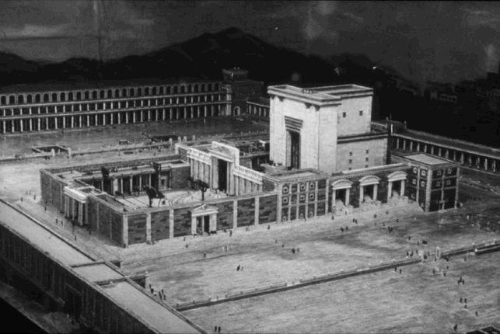
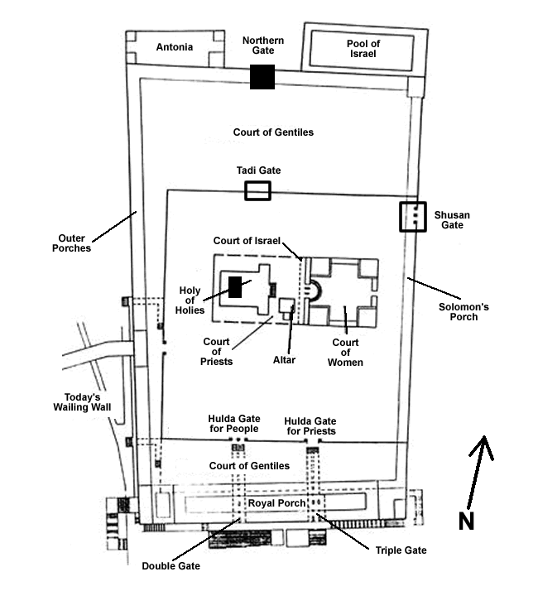
The Romans allowed the Jews to have their own police force guard the Temple area. The Levites, who formed this police force, stood guard at the gates and constantly patrolled the courts. They were to ensure that no unauthorized person should go where they were prohibited. This would be quite a task on feast days when tens of thousands would crowd into the Temple area. It is estimated that the Temple complex could contain more than two hundred thousand people at one time.
The Temple was the focal point of Jewish religion and worship. It was here that the blood sacrifices were made and the feasts of the Jews were celebrated.

The Jewish Sacred Year
Feast | Date | Purpose
The Passover  (cf. Lev 23:4-5) | Nisan 14 (March/April) | To remember the deliverance of Israel from Egyptian bondage.
The Feast of Unleavened Bread (cf. Lev 23:6-8) | Nisan 15-21 | Part of the Passover celebration. Ate unleavened bread and celebrated the beginning of the wheat harvest.
The Feast of Firstfruits (cf. Lev 23:9-14) | Nisan 21 | Part of the Passover celebration. To give thanks to God for His goodness in providing food from the Lord for the Israelites.
Pentecost (Feast of Weeks) (cf. Lev 23:15-22) | Sivan 6 (May/June) | Marked the end of the wheat harvest
The Feast of Trumpets (Lev 23:23-25) | Tishri 1 (Sept/Oct) | Known as Rosh Hashanah, it was the celebration of the new year (civil year).
The Day of Atonement (Lev 23:26-32) | Tishri 10 | .A day of fast set apart fro national repentance and atonement for sin. Known as Yom Kippur.
The Feast of Tabernacles (Lev 23:33-43) | Tishri 15-22 | Also known as “Booths” it commemorated Israel’s wilderness experience
The Feast of Lights (Dedication) | Kislev 25 (Nov/Dec) | Not found in the Mosaic Law. It was a celebration of the Maccabean cleansing and rededicating of the Temple. Known as Hanukkah
The Feast of Purim (Preservation) (Esther 9:20-32) | Adar 14-15 (Feb-March) | Not found in the Mosaic Law. Purim (“lots”) remembered God’s deliverance of Israel in the days of Esther.

