VII. Acts (124)
  - Introduction to Acts
    - Authorship of Acts
Both internal and external evidence of church tradition declare Luke to be the author.
    - Place and Date of Acts
Acts begins where Luke ends, with the resurrection of Christ. It ends with the apostle Paul’s imprisonment in Rome. Paul came to Rome around A.D. 61 and stayed there for two years (Acts 28:30). Therefore, the story of Acts ends in A.D., and this is the probable date for the writing of the book. This date seems reasonable since Acts makes no reference to the open persecution of Christians that erupted under Emperor Nero in A.D. 64, or to the martyrdom of Paul in the late sixties, or to the destruction of Jerusalem in A.D. 70.
    - Purpose of Acts
Luke’s purpose in Acts is tied into his purpose for writing the Gospel of Luke since both books are linked to the same audience and the first few verses of Acts reveals that it is a continuation of the former account. Therefore, at least one purpose in writing his two volumes was to give an accurate and orderly account of the development of Christianity.
The second purpose of Acts was to give a written defense of Christianity. Luke was concerned about the perceptions that people had about the church of Jesus Christ. Perhaps in conjunction with this apologetic purpose was to provide a kind of written defense for Paul, who would shortly be on trial in Rome.
A third purpose in writing Acts was to provide stability to the new faith, showing people that this movement was not some haphazard actions of zealous men but rather that workings of the Holy Spirit.
    - Theme of Acts
Acts 1:8 is the key to this book as it provides a three-prong outline of the book with respect to the movement of the Gospel from Jerusalem to Judea and Samaria, then to the rest of the world.
    - Special Considerations on Acts
      - Some Important Background Scriptures
Luke assumes his readers understood certain truths. For instance, Matthew 16:18 records Christ’s prophecy of the coming church. The church , which did not exist at the time Christ made the statement, would be “built,” and would be victorious over Satan. Acts would record the beginning and the building of this new entity known as the church.
In Matthew 12:38-40, Christ told the religious leaders that only one more sign would be given to Israel – His resurrection. The death and resurrection of Christ is the background and basis of the book of Acts.
Luke 21:23-24 gives the Lord’s statement that the city of Jerusalem would be destroyed. That generation of Israelites was under divine judgment for the national sin of rejecting its Messiah. There was an urgency in the apostles’ message to the Jews. They were to save themselves from that perverse generation (Acts 2:40). And Matthew 21:43 declares that the kingdom was taken from Israel (that generation) and given to another people (the Gentiles/the church).
      - Interpreting Acts
When Christ died and rose again, the New Covenant was instituted. The outworking of the New Covenant began in full force on the Day of Pentecost when the Holy Spirit came in His fullness and the church began. The Old Covenant, with all its laws and regulations, was set aside. While a sharp line of distinction can be drawn between the end of the old and the beginning of the new, it must also be remembered that it takes time for such a change to take place in human experience. Acts is the book that records this transition from the Old Covenant to the New Covenant.
Acts records the decline of the old system and the rise of the new. When interpreting Acts it is important to remember this. It is essential to note who the individual is that is being described and how much he knew. For example, well into the church age (the New Covenant era) there were Jews who had genuine faith in the Lord God of Israel but had no knowledge of Jesus Christ. There were others who had responded positively to the ministry of John the Baptist but who knew almost nothing about the One he had announced. It is important, therefore, to observe carefully who the text is focusing on in order to properly interpret that text. Acts is uniquely a book of transition.
      - Signs and Miracles in Acts
Very infrequently in the Bible we find God setting aside His natural laws and working miracles through some chosen individual. But Acts records many such miraculous events, as the Holy Spirit worked powerfully through certain men. Why were these miraculous works employed in the days that Acts records? There are probably two primary reasons for this outpouring of the supernatural.
        - First, these miracles authenticated the new message that was being preached by the apostles. With so many religious ideas around and with so many claiming to be sent from God, the claim of the apostles would be seen as simply another to be added to the long list. But miracles set this new faith apart, demonstrating powerfully that it was indeed from God (Note how Peter carefully integrated the miraculous events with his sermons in Acts 2;15, 33; 3:12; 4:16). It should be noted that God authenticated the Old Covenant through miracles at Mt. Sinai. The message and the messenger (Moses) were clearly seen as being from God. If, therefore, God was giving a New Covenant, it was reasonable to expect that it would be authenticated through miracles also.
        - Second, miracles were used to keep the new movement together. The church would easily have divided along lines of race and prejudice if miracles had not been employed to make it clear to Jews, Samaritans, and Gentiles that the church was to be one.
  - Summary of Acts
    - Introduction (1:1-2:4)
      - The Prologue (1:1-5)
Luke begins Acts, as he did his Gospel, with a long introductory sentence, identifying three major themes:
        - First, this second volume would be an accounting of the words and works of Christ following His ascension back to heaven.
        - Second, this volume would show that future ministry would be carried on through the apostles – those men that He had chosen to represent Him and preach the gospel.
        - Third, this volume would show that future ministry would be done through the Holy Spirit, who would empower the apostles and others for service.
Luke also relates Christ’s two main objectives were accomplished during the forty days between His resurrection and ascension:

- First, during those days the Lord Jesus gave many proofs that he was alive and had been raised bodily from the tomb. This was the basis of the message of the apostles. It validated the Christian faith (cf. 1 Cor 15:12-20).
- Second, the other accomplishment of those post-resurrection days was Christ’s instruction of the apostles. There were many truths that they could not understand until they had experienced the events of Christ’s death and resurrection.

    - The Ascension of Christ (1:6-11)
Christ’s ascension took place near Bethany on the eastern side of the Mount of Olives (Luke 24:50). Before he departed into heaven, His disciples asked Him when He would restore the kingdom. He did not deny the future establishment of the kingdom of Israel, but He informed them the timing was God’s decision.
Christ’s ascension reveals the approval of the Father of the work of the Son.
    - The Preparation for the Witness (1;12-2:4)
The first duty of the disciples was to return to Jerusalem and wait. Much time was spent in prayer with other believers, who gathered with them (Acts 1:14). During this time, they dealt with the practical issue of replacing Judas Iscariot’s spot among the Twelve. Peter saw this as a necessary step to fulfill OT prophecy (cf. Ps 69:25; 109:8). The two qualifications were (1) he had to have seen the resurrected Christ and (2) he had to have been a witness of Christ’s ministry from the days of John the Baptist. Two men fit the description but the lot went to Matthias. Perhaps the twelfth man was needed because of rule in the future kingdom (cf. Matt 19:28).
The disciples was expecting some manifestation of the Spirit in those days. And He came as a violent, rushing wind. The wind symbolized the Spirit’s working in the OT (cf. Ezek 37:9, 14; John 3:8). They also saw tongues of fire resting on each of them. Fire oftentimes speaks of divine presence (cf. Ex 3:2; 40:34-38). And, as the Spirit came upon them, they were able to speak in tongues. It provided the opening to the preaching of the Gospel at Pentecost.
  - The Gift of Tongues
Generally, spiritual gifts have been given to Christians to benefit other people (1 Cor 12:7; Eph 4:12). Spiritual gifts are given sovereignly by the Holy Spirit to enable believers to serve God effectively in some particular way (1 Cor 12:11). Each spiritual gift was given for a specific reason.
    - The Definition of Tongues
The definition and purpose of the gift helps us to understand the nature of this gift. The definition (description) of tongues is given in Acts 2:4-11. Luke describes the gift in terms of known human languages. The tongues were unknown to those who were speaking. Therefore, the definition for the gift of tongues might be “the God-given ability to speak in a language that is unknown to the speaker.” Such an ability is clearly supernatural.
    - The Purpose of Tongues
The purpose of tongues is explained by the apostle Paul in 1 Corinthians 14:20-22. Tongues are said to be a sign. If something is a “sign,” then two questions must be asked and answered: first, a sign to whom? And, second, a sign of what? Paul states rather clearly that tongues were not a sign to believers. This fact alone would eliminate a large number of ideas, such as that tongues is a sign to believers that they have been baptized by the Holy Spirit. Tongues were, however, a sign to “this people” (1 Cor 14:21). The quote Paul makes is from Isaiah, and the context of Isaiah identifies “this people” as Israelites. But the sign, according to the apostle Paul, is not for believers. Therefore, we are to conclude that tongues were given as a sign to unbelieving Israel. The Jews were always looking for signs (1 Cor 1:22).
The context of Isaiah 28 and other portions of the OT must be considered to understand the significance of tongues. In the OT God entered into a covenant with Israel at Mt. Sinai. This “Old” Covenant was a conditional covenant, that is, God’s blessings were conditioned on Israel’s obedience. God would bless if Israel would obey. If Israel disobeyed, then the disciplines of God awaited them. If Israel failed to respond to God’s discipline and repent, then God would bring greater discipline on them.
The final level of discipline by God was bringing foreign invaders into Israel, who would take them over. So when Israel heard the language (tongue) of these foreigners, they knew God’s judgment was upon them (cf. Deut 28:49). Tongues were a sign to unbelieving Israel of coming (or present) judgment on Israel.
In the NT, Jesus pronounced final judgment on that generation of Israelites because they had rejected (and would murder) their own Messiah (cf. Matt 23:33-38). On the day of Pentecost tongues were heard. Peter warned Israel that their generation was corrupt and they needed to be separated from their own generation (Acts 2:40). This separation , of course, could be accomplished by obeying God – in this case, believing in Jesus as their Savior-Messiah, God did judge that generation in A.D. 66-73, just as prophesied, by using the foreign army of Rome.
    - The Uses of Tongues
Since the content of tongues was praise to God (1 Cor 14:2), there could be spiritual benefit to those who heard and understood. But it was a complicated way to edify believers. This, however, was not the major purpose of tongues. Paul encouraged the Corinthian church to seek better gifts to edify the congregation. And since the church was not the place for the gift to be used, Paul did not do so. He probably used this gift as he went from place to place and evangelized the Jews, who were looking for such signs.
  - The Witness of Jerusalem (2:5-8:3)
    - At Pentecost (2:5-47)

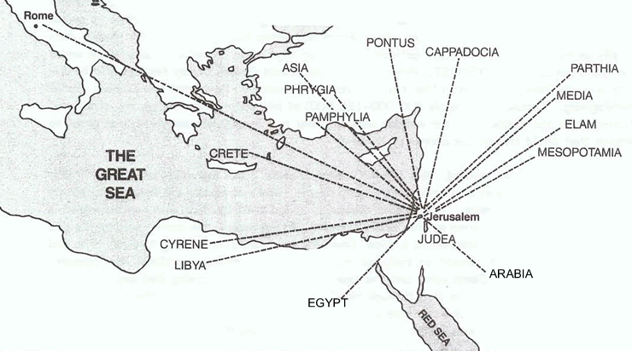
The Jews, who were dispersed over the world, would come in great numbers to Jerusalem to celebrate the key Jewish feasts. The would probably know Greek and Aramaic, as well as their own dialect. These pilgrims were amazed to hear a small band of Galileans speaking (praising God) in their own unique dialects (2:6-8). This sensation caused great interest and confusion among the Jews; they desired to know how these things could be.
Peter, speaking for the apostles, immediately took his hearers to the prophet Joel. Peter used Joel to communicate two points: first, God does pour forth His Spirit on man, and second, anyone who will call on the Lord will be saved. Peter then preached on the recent past regarding Israel’s crucifixion of Jesus of Nazareth, who by signs, miracles and finally by resurrection had been authenticated by God as the Messiah (2:36). The tongues speaking was proof of the fact that the resurrected Jesus was at the Father’s right hand pouring out the Holy Spirit on people (Acts 2:33). When the people, feeling helpless and hopeless, cried out, “What shall we do?” (2:37). Peter told them that they needed to change their minds (“repent”) concerning Jesus of Nazareth, and to change their public identification (2:38). The national decision, which led to Christ’s crucifixion, was that He was a blasphemer and an agent of the devil himself. They must change their view and acknowledge Him as the Messiah. And they were to identify with Him publicly through water baptism. Some three thousand responded favorably to Peter and were added to the church.
When these people believed, they cut themselves off from much of Jewish social and religious life. The church now became their central concern. During the next months much time was spent together in being taught the doctrines of the New Covenant, worshiping, praying, and ministering (Acts 2:42-47).
    - Of Peter and John (3:1-4:31)
Luke stated that the apostles worked many signs (Acts 2:43). He then recorded one such sign. It illustrated the fact that the apostolic miracles authenticated the message and the messenger, and gave openings for the preaching of the gospel. Peter and John healed a man who had been lame for forty years (cf. 4:22). This genuine miracle gave Peter an opportunity to preach again about the resurrection of Jesus Christ (3:11-26). The response was great, increasing the number in the Jerusalem church to five thousand (4:4). But this incident also gave the apostles their first taste of persecution from the religious leaders. When questioned, Peter responded as before by associating guilt of the murder of the Messiah to his hearers and declaring that the resurrected Christ was the Messiah. The rulers were amazed by the apostles’ boldness and use of the Scriptures, and they could not deny the validity of the miracle. Nevertheless, they issued an order that there was to be no more preaching in the name of Jesus (4:18). Peter and John voiced their decision to ignore such a decree (4:19-20). They returned to the other believers and together with them prayed for boldness (4:23-31).
    - Of the Apostles (4:32-5:42)
Unity, love, power and growth characterized the church in the days that followed (Acts 4:32-35). Nevertheless, opposition was soon to follow. From the outside, persecution by rulers began to grow. On the inside, Satan attempted to destroy unity and purity through sin in the assembly. The story of Ananias and Sapphira is one such attempt (Acts 5:1-11). The married couple purposefully lied, and they immediately paid for this sin with their lives. The result was great fear came upon everyone who heard about this incident and another surge forward in the life of the church (Acts 5:12-16).
The Jewish leaders again arrested the disciples. And again, Peter preached the resurrected Christ. So the leaders were now intent on killing them (Acts 5:33); however, following the advice of Gamaliel, one of the great teachers of that day, they chose instead just to flog the disciples, hoping the beating would dissuade them to keep quiet. But to the contrary, the disciples rejoiced to be counted worthy to suffer for Christ and continued preaching (Acts 5:42).
    - Of Stephen (6:1-8:3)
As a result of a financial problem involving the care of widows, Stephen enters the story. He was a man of excellent character and spiritual wisdom (6:3). He not only dealt successfully with the financial problem (along with the other men who were selected as deacons), but he also ministered the Word of God and performed miracles. He was a powerful witness of Jesus and no one was able to refute him. But after false charges were brought against him, he was taken to the Great Sanhedrin. In his defense (7:2-53), Stephen skillfully refuted his accusers and concluded his message with a severe denunciation of the rulers. This boldness led to his death by stoning. The church had its first martyr. The death of Stephen was the beginning of a great persecution of the church (8:2). This persecution was led by a man named Saul (8:3).
  - The Witness in Judea and Samaria (8:4-12:25)
    - Of Philip (8:4-40)
For the first time the church leaves the confines of the Jerusalem area and spreads to other localities. The persecution of the church had the beneficial effect of the gospel spreading to other people. The story focuses on Philip, who was one of those chosen to deal with the financial problem (Acts 6). Philip went to Samaria preaching the gospel and working miracles. The result of his ministry was the remarkable conversion of multitudes of people. When the apostles heard of the evangelism among the Samaritans, they sent Peter and John to verify what was happening. Through apostolic miracles the Lord showed that the Samaritans were genuinely saved, and that they were equals in the church. This unique experience at Samaria was necessary to keep the movement together and ensure the unity of the church.

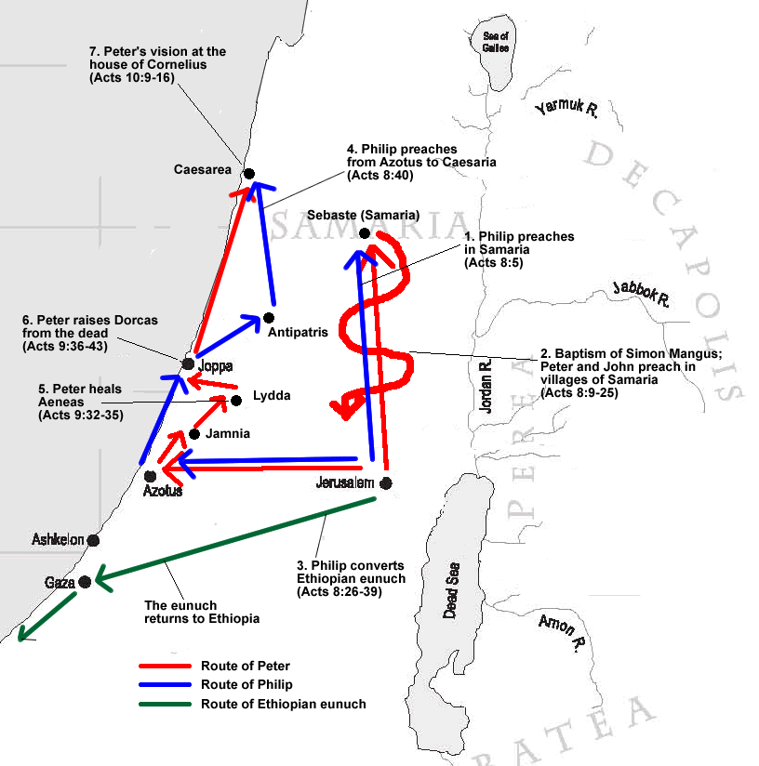
    - Of Saul (Paul) (9:1-31)
Luke now picks up from 8:3, continuing the narrative about the religious leader Saul. Not being content with local persecution in Jerusalem, Saul requested and received extradition papers for Christians found in other places. Thus, we find him heading to Damascus to arrest Christians. But on the way, he sees the rise and glorified Christ. He is temporarily blinded and led into the city, and a man named Ananias is sent to restore his sight and encourage him in his new-found faith. Saul then spent some time in Arabia, and later returned again to Damascus (cf. Gal 1:15-17).
Saul (better known as Paul) began to preach that Jesus of Nazareth is the Messiah. His preaching caused great distress among the unbelieving Jews, and they sought to kill him. The great persecutor had become a powerful preacher of the faith he once tried to destroy. The Lord revealed to Paul that He had a special ministry for him among the Gentiles (cf. Acts 22:3-21; 26:6-23 on Saul’s conversion). Paul fled from Damascus, went to Jerusalem, and then journeyed to Tarsus (Acts 9:26-30).
    - Of Peter (9:32-11:18)
Peter ministered in a number of cities, but it was the incident of Caesarea that was particularly noteworthy. There a number of Gentiles (who were not proselytes to Judaism) came to faith in Jesus Christ. After they responded to Peter’s message, the Holy Spirit confirmed the validity of their faith through supernatural signs – the same kind as had occurred to the Jews at Pentecost. This made it clear to the Jewish believers that God had brought Gentiles into the church as equals with the Jews. (This lesson would have to be relearned a number of times in the years that would follow.)
    - Of the Church (11:19-12:25)
A new phase of evangelism begins to enter the life of the church as the gospel goes to the city of Antioch of Syria. Paul now becomes an important part of Gentile evangelism (11:19-26). The church at Antioch became the first church to be predominantly Gentile in its make-up. It is at Antioch that Paul and Barnabas first ministered extensively together to the Gentiles.
It is at this time another wave of persecution hit the Jerusalem church. This persecution, led by Herod Agrippa I (a grandson of Herod the Great), apparently was carried out in order to find favor with the Jews. The first apostle to be martyred (James) was killed, and Peter was thrown into prison. These were dark days for the church, but God was still working mightily and the gospel continued to spread (Acts 12:24).
  - The Witness to the Uttermost Part of the Earth (13:1-28:31)
    - The First Missionary Journey (13:1-14:28)
In the timing of God the moment had arrived for the gospel to spread out to the world as it never had before. While praying and fasting, the believers in Antioch learned what the will of God was. Perhaps through one who had the gift of prophecy, Paul and Barnabas were selected for a special work. This ministry would take them into new areas with the gospel.

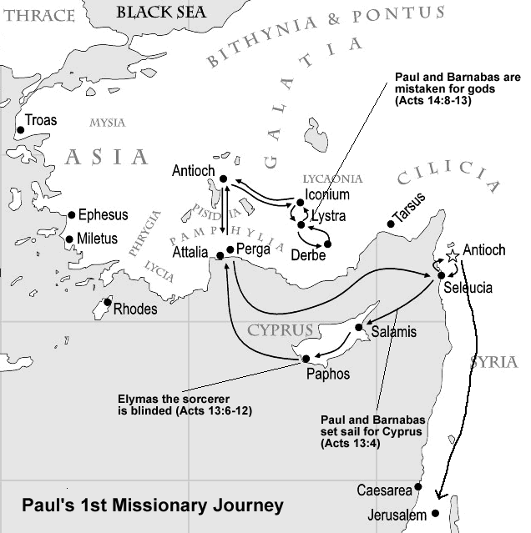
The missionaries’ first stop was the island of Cyprus, where they evangelized the cities of Salamis and Paphos. They then sailed to the shores of Asia Minor, proceeding inland to the cities of Antioch (of Pisidia), Iconium, Lystra, and Derbe. In each city they evangelized and started churches. But they also experienced the hatred and persecution of the Jews. The two missionaries returned to their home base of Antioch (of Syria) and reported all the wonderful things that God had done.
    - The Jerusalem Council (15:1-35)
While teaching again at Antioch, Paul and Barnabas were confronted by Jews from Judea. These Jews were teaching that, in order to be saved, people (Gentiles included) had to be circumcised and keep the law of Moses. Paul and Barnabas disagreed with them, and heated debates followed. The problem was of such magnitude that it was decided they would go to Jerusalem and there, with the apostles, work out the solution. This event was very serious and extremely important in the history of the church. This theological wedge could split the church in two. If the rites of Judaism were attached to the New Covenant, then there probably would have been division. After discussing the issue and listening to the testimonies of Peter, Paul and Barnabas, it was decided that Gentiles did not have to keep the law to be saved. However, Gentile Christians were encouraged to respect the feelings and thinking of the Jewish Christians and not purposefully offend them.
    - The Second Missionary Journey (15:36-18:22)

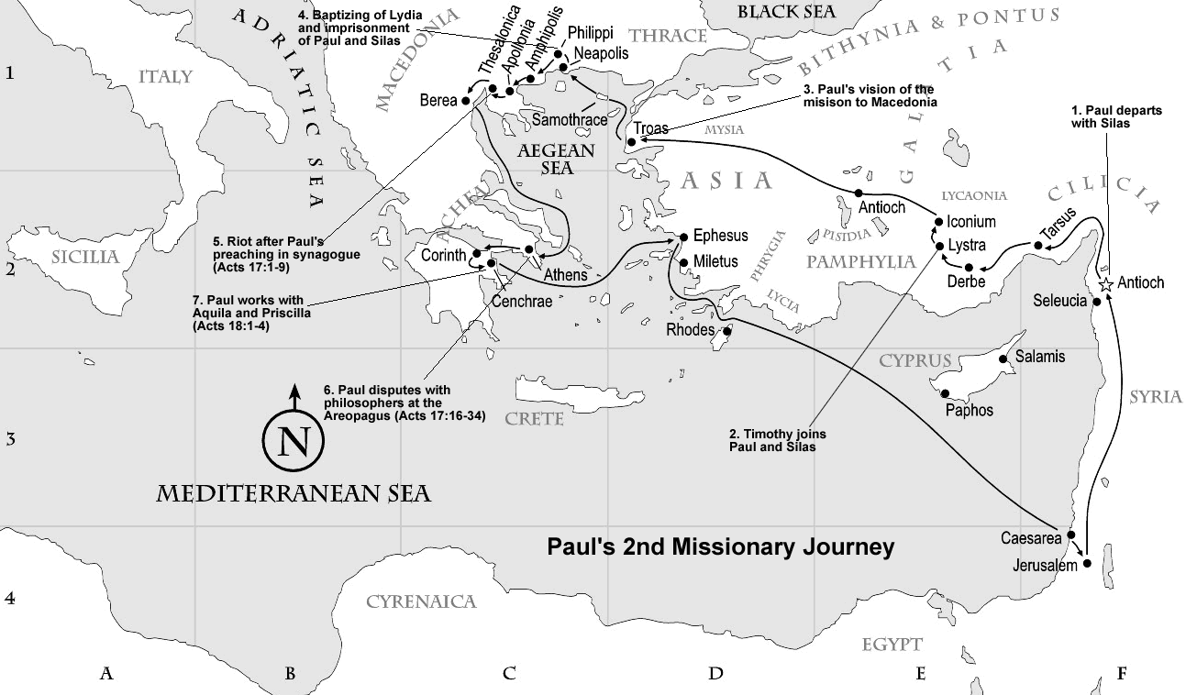
Paul realized that he needed to check on the new churches that were started on the first missionary journey. When his companion Barnabas wished to take his nephew John Mark along, Paul refused to allow it. (Mark had failed to continue with them on the first journey, but instead had left the missionary group.) This caused a division between the two men, resulting in a parting of company. Barnabas took Mark and revisited Cyprus. Paul chose Silas to go with him. Paul and Silas confirmed the churches of Asia Minor that had been started on the first journey. Also in Asia Minor, Timothy joined the missionary group. After being kept by the Holy Spirit from entering certain provinces (16:6-7), the missionary party arrived at Troas. Here Luke joined them, and Paul saw the “Macedonian vision,” in which a man requested the gospel for that territory. They went to the cities of Philippi, Thessalonica, Berea, Athens, and Corinth. Where there was a synagogue in these cities, Paul would go there first and preach Jesus. Paul would speak there until he was forced to leave. Often this attention was shifted next to the Gentiles, from whom he usually had a better response. Paul remained in the city of Corinth for a year and a half, which was the longest stay in any city on the second journey. In most of these cities churches were started.

    - The Third Missionary Journey (18:23-21:16)
After spending a period of time in Antioch of Syria, Paul returned to his missionary activity. After journeying through the regions of Galatia and Phrygia, he went to Ephesus, where he ministered for about three years, longer than any other place on the third journey. His ministry there was extremely effective (19:20). He then returned to Macedonia and Greece to see that the churches were doing well. Following this he went to Troas on his way to Jerusalem, where his journey ended. All along this trip to Jerusalem, Paul had been warned that trouble awaited him there. Paul was arrested in Jerusalem, beginning about four years of imprisonment.
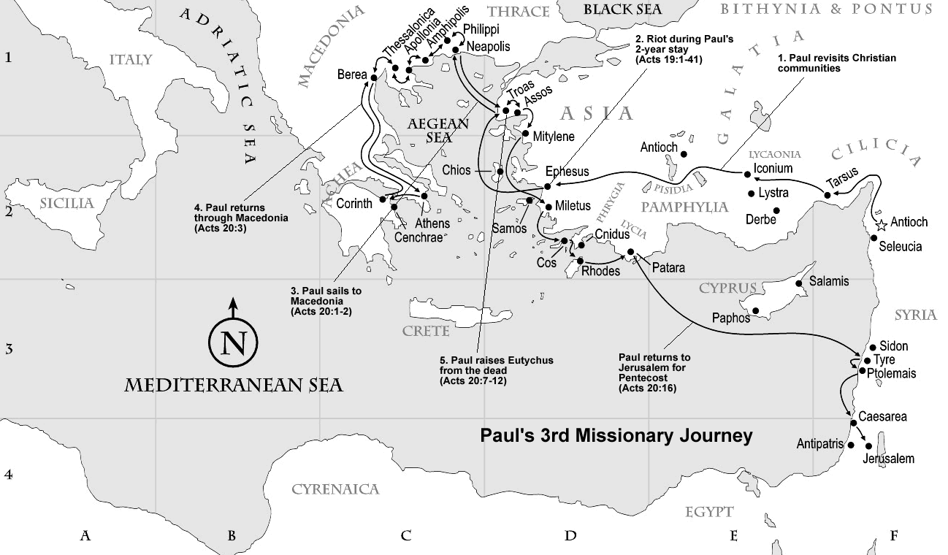
    - The Journey to Rome (21:17-28:31)
Paul gave a number of defenses before Jewish and Roman authorities. His life was very much in danger in Jerusalem, and he was moved to the Roman-dominated city of Caesarea. After giving defenses before Festus, Felix, and Agrippa, Paul demanded to be tried as a Roman citizen in Rome. Since this was his right, Paul was transported to Rome. The apostle’s ship left late in the year, which was not a weather-wise time for sailing the Mediterranean. The ship was caught in a terrible storm and driven some 435 miles to wreck on the island of Miletus. Here, after a stay of three months, Paul was taken to Rome (Acts 27:1-28:16).
Paul was under house arrest in Rome, but did have the freedom to preach the gospel to those who came to visit him. Most likely, Paul was freed after his two years in Rome and continued his missionary activity. But having told of the coming of the gospel to Rome, Luke’s purpose in writing Acts had been accomplished.

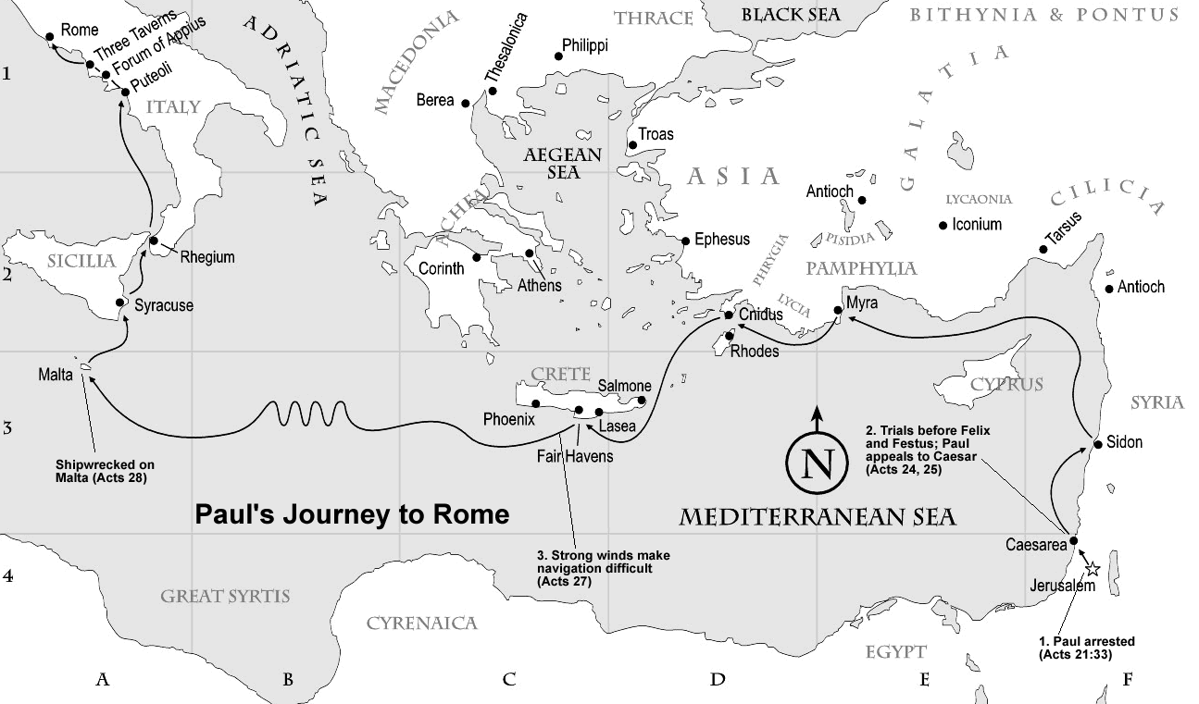

  - Life of Paul
A Chronology of Paul’s Life

Date (A.D.) | Events
1 | Birth of the apostle Paul
14 | Paul sent to Jerusalem to study under Gamaliel
34 | Paul’s conversion (Acts 9)
44 | Paul’s ministry at Antioch
47 | Paul’s first missionary journey
50 | Paul’s second missionary journey
54  58 | Paul’s third missionary journey  Paul is imprisoned at Caesarea
60 | Paul’s first Roman imprisonment
62 | Paul is released from his Roman imprisonment
64 | Paul’s second Roman imprisonment: his death

    - The Influence of Judaism on Paul
      - Paul was a Hebrew Patriot
Although he was sent to the Gentiles, Paul always had a deep love for his own people (c.f. Rom 3:1; 9:1-3). Paul’s early training in the law and his learning of a trade (tentmaking) reveal that he came from a family who lived by true Israelite ideology.
      - Paul was a Pharisee
Paul’s father was a Pharisee (Acts 23:6) and Paul himself was a zealous Pharisee (Phil 3:5). He outstripped his contemporaries in his advancement in Pharisaism with its emphasis on knowledge of the Scriptures, external righteousness, fasting and tithing.
      - Paul was a Student of the Old Testament
In the synagogue at Tarsus, Paul would have learned the Hebrew Scriptures. Up until the age of twelve he would have learned to write the Hebrew characters, studied the Law and the Prophets, and mastered Jewish history. At the age of thirteen he was probably sent to Jerusalem to advance his education under the master teacher Gamaliel (cf. Acts 22:3).

      - Paul was a Missionary
As a pupil of Gamaliel, Paul would have known the goal of one proselyte per year for every Jew. The idea of spreading God’s truth to others was instilled in him from his youth. This idea would be sanctified and used by the risen Christ in the propagation of the gospel during the adult years of Paul.
    - The Influence of Hellenism on Paul
      - The City of Tarsus
Paul was born and reared in Tarsus, the capital of the Roman province of Cilicia. Tarsus was founded as a Greek city-state in 171 B.C. by Antiochus Epiphanes. Evidence points to the fact that Jews settled in Tarsus from the founding of the city and were given rights as citizens. Paul clearly claimed to be a Roman citizen (e.g. Acts 21:39), and it could be that this citizenship had long been a part of Paul’s family. “The rights of citizenship could only be got by inheritance from a citizen father, apart from exceptional cases in which it was bestowed by a formal law on an individual as a reward for services rendered to the city; but such cases were comparatively few in any one city, for the right was jealously guarded.” Paul’s Roman citizenship proved valuable as he traveled the Roman world preaching the gospel.
      - The Mystery Religions
    - Paul’s Personal Life
It was common for an individual to be known by several names in the Roman world of Paul’s day. Paul was his Latin name and Saul was his Hebrew name. He may have always had these names and they are unrelated to his conversion; that is, his name was not changed to Paul after his conversion.
    - Paul’s Conversion
Paul’s conversion was brought about suddenly when he met the risen Christ on the Damascus Road.

Chronology of Acts and the Epistles

A.D. | Peter and Paul | NT Epistles | Chpts. in Acts
33 | Peter’s Ministry  Paul’s Conversion | James | 1-2
47 | Paul’s 1st Journey | Galatians | 13-14
48 | Jerusalem Council  Peter and Paul | None | 15
50 | Paul’s 2nd Journey | 1 Thessalonians  2 Thessalonians | 15-18
53 | Paul’s 3rd Journey | 1 Corinthians  2 Corinthians  Romans | 15-21
57 | Paul’s Arrest: Jerusalem | None | 21-24
58 | Paul in Prison: Caesarea | None | 24-26
60 | Paul in Prison: Rome | Ephesians  Colossians  Philemon  Philippians | 27-28
62 | Paul’s Final Travels, Martyrdom | 1 Timothy  Titus  2 Timothy | None
64 | Nothing | Written before A.D. 70  Jude  1 Peter  2 Peter  Hebrews  Written after A.D. 70  Jude  1,2,3 John  Revelation | None

