God and His Law

Objectives

- Complete Session 4 – God and the Exodus
- Review Session 5 – The Covenant
- Time permitting, review Quick OT Survey and/or One-word summaries of OT Books

Notes

Review
Key word for Genesis: Beginnings
Key word for Exodus: Redemption

- The Covenant
The Covenant with the Nation (Ex 19:3-7)
Nature of the Covenant
(1) “Covenant” defined – contract; commitment; relationship (cf. Jeremiah 31:33)
(2) Hesed – God’s covenant faithfulness (cf. Lamentations 3:22)

Elements of the covenant
(1) God based His covenant on His acts in history (Ex 9:4)
(2) God gave conditions for the covenant – unlike Noahic & Abrahamic covenants (see stipulations above)
(a) Obey God fully
(b) Keep God’s covenant
(3) The covenant contains the promises of God (see promises above; cf 1 Peter 2:9)
(a) Israel would be God’s treasured possession
(b) Israel would be a Kingdom of Priests (Exodus 19:6 – Priesthood of believers)
© Israel would be a Holy Nation

The Ten Commandments (Ex 20)
(1) NT abrogates certain Jewish dietary laws (cf. Mk 7:19)
(2) Relevance for today

The Numbering of the Commandments
(1) Jews – Believe 1st commandment begins with “I am the Lord your God”
(2) Catholics & Lutherans – Believe 1st commandment is verses 3-6 and form commandment 10 by dividing verse 17 into two commandments.
(3) Baptists – Believe verse 2 is the basis for the commandments but is not itself a command and the 1st commandment begins with verse 3 and verses 4-6 constitute the 2nd commandment.
- The Ten Commandments

Form of the Ten Commandments
Content: Exodus 20 and Deuteronomy 5
Reference to term: Exodus 34:28, Deuteronomy 4:13; 10:4
Other Names: “Decalogue” or ten words; Moral laws as opposed to civil and religious and civil laws as reflected in the Book of the Covenant
The Ten Commandments and Their Meaning for Today (Ex 20:1-17)
Commandment 1 – No other gods (20:3) God is monotheistic (Deut 6:4 shema); God is holy (against Pantheism; Leviticus 19:2; 1 Peter 1:15 – Be holy as I am holy)
Commandment 2 – No images (20:4-6) We tend to worship the image even when it is only representative (cf. Bronze snake in Numbers 21:4-9 with 2 Kings 18:4 and Gideon’s Golden Ephod in Judges 8:23-27). What kind of images do we worship today?
Commandment 3 – Reverence God’s name (20:7)
Commandment 4 – Keep the Sabbath (20:8-11) The Jewish Sabbath begins Friday at sunset and continues until sunset on Saturday. Jewish Christians worshiped at the synagogue on the Sabbath and again on Sunday to worship and celebrate Christ’s resurrection. Later, they worshipped exclusively on Sunday.
(1) The Bible lacks specific instructions for the celebration of the Lord’s day, but…
1 Cor 16:7 “Upon the first day of the week let every one of you lay by him in store, as God hath prospered him.”
Acts 20:7 “On the first day of the week we came together to break bread.”
The reality of the Sabbath rest is found in Christ and we are not to judge or be judging others on this matter (Hebrews 4:1-11; Colossians 2:16-17; Romans 14).
(2) Observations about the Sabbath:
(a) Jesus is Lord of the Sabbath (Matthew 121:8)
(b) Jesus healed on the Sabbath
(c) Jesus 7 the Father works – good words – on the Sabbath (John 5:1-17)
(d) Jesus went out of his way to do good works on the Sabbath
(e) This is the only commandment that is not specifically repeated in the NT for the church to keep (Project for bonus points: Try to find as many NT references to each of the 10 commandments and put it into a 2-column chart to present to class)
Commandment 5 – Honor parents (20:12)
The book notes that this command is given to adults, but I believe both children and adults are in view, particularly when you see it used specifically with reference to children in Ephesians 6:1-2 and in light of passages like Proverbs 6:20 (“My son, keep your father’s commands and do not forsake your mother’s teaching.”). Also, later in the explanation of these commands, children that curse their parents are to be stoned. This carries with it the idea that cursing their parents does not honor their parents. Also, the word honor carries with it the idea of obedience (again, Eph 6:1)
Commandment 6 – No murder (20:13)
This command takes its root in the covenant with Noah back on Genesis 9:6, where we read that “Whoever sheds the blood of man, by man shall his blood be shed; for in the image of God has God made man.”
From Zach Smith, Does Exodus 20:13 Prohibit Capital Punishment.
“It is used forty-three times in the Old Testament (Wigram, 2001, p. 1190), and often is translated as “murder.” Koehler and Baumgartner defined ratsach as “kill,” “murder,” or “slay” in the verbal forms, and as “manslayer” in the participle form. In the participle, there appears to be no difference between intentional and accidental killing (Holladay, 1988, p. 346). Brown, Driver, and Briggs defined ratsach as “murder, slay,” and noted also that the distinction between unintentional and intentional killing does not seem to be carried by this word (2001, p. 953). Domeris spoke of the use of ratsach in Exodus 20:13:
As it stands, it is a blanket prohibition against the taking of a person’s life by an individual or by a mob, who target an individual, with all the attendant savagery. In the wider context of the OT, the prohibition may be defined more narrowly as the taking of a life outside of the parameters (as in the case of war or capital punishment), laid down by God… (1997, 3:1188-1189, parenthetical item in orig.).”

Jesus expands on this command in Matthew 5:21-26 associating anger with murder.

21"You have heard that it was said to the people long ago, 'Do not murder,^{[a]} and anyone who murders will be subject to judgment.' 22But I tell you that anyone who is angry with his brother^{[b]}will be subject to judgment. Again, anyone who says to his brother, 'Raca,^{[c]}' is answerable to the Sanhedrin. But anyone who says, 'You fool!' will be in danger of the fire of hell. 23"Therefore, if you are offering your gift at the altar and there remember that your brother has something against you, 24leave your gift there in front of the altar. First go and be reconciled to your brother; then come and offer your gift. 25"Settle matters quickly with your adversary who is taking you to court. Do it while you are still with him on the way, or he may hand you over to the judge, and the judge may hand you over to the officer, and you may be thrown into prison. 26I tell you the truth, you will not get out until you have paid the last penny.^{[d]}

What Jesus is saying here is this: "In the old days men condemned murder; and truly murder is forever wrong. But I tell you that not only are a man's outward actions under judgment; his inmost thoughts are also under the scrutiny and the judgment of God. Long-lasting anger is bad; contemptuous speaking is worse, and the careless or malicious talk which destroys a man's good name is worst of all." The man who is the slave of anger, the man who speaks in the accent of contempt, the man who destroys another's good name, may never have committed a murder in action, but he is a murderer at heart.

Commandment 7 – No adultery (20:14)
Compare Matthew 5:27-30
27"You have heard that it was said, 'Do not commit adultery.'^{[a]} 28But I tell you that anyone who looks at a woman lustfully has already committed adultery with her in his heart. 29If your right eye causes you to sin, gouge it out and throw it away. It is better for you to lose one part of your body than for your whole body to be thrown into hell. 30And if your right hand causes you to sin, cut it off and throw it away. It is better for you to lose one part of your body than for your whole body to go into hell.
Also adultery is related to divorce and remarriage in Matthew 5:31-32:
31"It has been said, 'Anyone who divorces his wife must give her a certificate of divorce.'^{[a]} 32But I tell you that anyone who divorces his wife, except for marital unfaithfulness, causes her to become an adulteress, and anyone who marries the divorced woman commits adultery.
Commandment 8 – No stealing (20:15)
Basic idea of stealing: Taking what does not rightfully belong to you. This is also a constitutional right.
Extended meaning:
(1) Taking credit for accomplishments that are not ours.
(2) Downloading music, videos, programs from the internet without purchasing the license to use them.
(3) Taking office supplies for personal use.
(4) Committing to a certain time of work and goofing off during that time.
(5) Not correcting a clerk’s error in your favor
(6) Not paying your employees fair market wages
(7) Not paying a legitimate bill
(8) Cheating on your taxes
(9) Borrowing and not returning something.
(10) Wrongfully capturing a cable signal without paying for it.
(11) Getting something by fraud (related to bearing false witness).
(12) Not tithing.
(13) Corporate stealing:
Embezzlement - misappropriation of something that has been entrusted) and Extortion; ex. Under reporting income, creating false bills; creating phantom employees
Extortion – obtaining money, behaviour, or other goods and/or services from another by wrongfully threatening or inflicting harm to this person, reputation, or property; ex. Blackmail (specifically, extortion by threatening another's reputation with the disclosure of incriminating statements (true or false) about him) and metaphorically but not legally, usury or price gouging. Not robbery (because exortion is somewhat voluntary where robbery involves the threat of immediate force).

Commandment 9 – No false testimony (20:16)
Often seen with respect to testimony in a court of law (or at “the Gate” in the OT where such judgments are made). The Bible requires 2 witnesses. If a person bears false witness (perjury) against an accused, and it is found out, that person would be liable to face the same judgment made to the accused.
Jesus associates this sin, along with murder with the devil and those who do this as the devil’s children in John 8:44
“You belong to your father, the devil, and you want to carry out your father's desire. He was a murderer from the beginning, not holding to the truth, for there is no truth in him. When he lies, he speaks his native language, for he is a liar and the father of lies.”
Few things the Bible says that God cannot do – one of those is that God cannot lie (Numbers 23:19; Titus 1:2; Hebrews 6:18)
God hates liars and final judgment is reserved for them (Prov. 6:16-19; Rev. 21:8)
Some include here… rumors, insinuations, gossip, and slander. While these are not good, it is difficult to derive from this command because it specifically speaks of things that are “false.”
Exceptions: Hebrew midwives, Rahab the harlot, Corrie Ten Boom
Commandment 10 – No coveting (20:17)
Desiring what is not yours. Perhaps the most inward of all the commands and disobedience to this is the seedbed for violating the other commandments. Paul talks about this in Romans 7 (cf. James 4:1-2).
The Book of the Covenant (Ex 20:22-23:33)
This name is taken from Exodus 24:7 and relate to the Ten Commandments as the “wherefore” relates to the “what.” The Ten Commandments deal with “you shall not” and the Book of the Covenant deals with the “if and when” situations. So the Book of the Covenant applies the Ten Commandments to particular situations. Some of the laws here have been superseded / abrogated by the time of NT (e.g. laws concerning slavery)
Basic Principles:
(1) Religious and civil laws come from the Lord.
(2) Human life is of supreme value.
(3) Gross retaliation is prohibited.
(4) Class distinction is prohibited.
(5) Weaker members of society should be protected.

- The Tabernacle (Exodus 25-31; 35-40)

Essence: The Tabernacle was the symbol of God’s presence in the midst of his people.
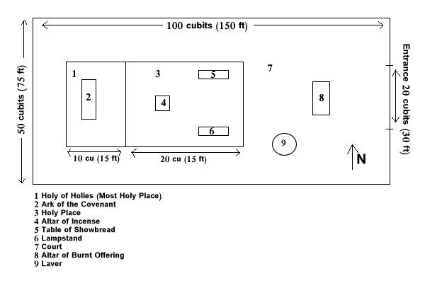
The Holy of Holies (25:10-22; 26:1-37) – Also known as the Most Holy Place. Contained the ark of the covenant (approx. 45” x 27” x 27”), which came to be regarded as the throne of God. Only the High Priest (line of Aaron) could enter and only once a year (Day of Atonement) to make atonement for the people’s sins. A bell would be tied to the High Priests ankle with a rope leading out just in case the High Priest was killed by God and they would have to pull him out. Not that there is a thick curtain (4 inches) separating the Holy of Holies from the Holy Place. This curtain (veil) was torn when Christ died (Matthew 27:51), thus, symbolizing the opening up of access to God through the blood of Christ (cf. Heb 4:14-16; Eph 2:18)
The Holy Place (26:1-37) – Only priests (Levites) could enter here, which they did every morning. Here was the Table, the Lampstand and the Altar of Incense.
The Table of Showbread (25:23-30) – The table for the bread of the Presence also held the utensils for drink and incense offerings. The bread reminded the people that God was present with them and that He gave them the necessities of life.
The Lampstand (25:31-40) – The Lampstand stood in the holy place as a reminder that the way to God is always lighted.
The Altar of Incense (30:1-10) – Smoke from the burning incense represented the eternal presence of God with His people. (cf. Rev. 8:3-4 where Bowls of incense represented the prayers of the people)
The Court – The court was the enclosed outer area that the people could enter. This area contained the bronze basin and the altar for the burnt offerings.
The Laver (30:17-21) – Also known as the Bronze Basin; the basin contained water the priest used for washing and signified the need for purity on the part of the person who comes to meet God.
The Altar of Burnt Offering (27:1-8) – This was used for burning animal sacrifices and signified the people’s need for forgiveness.
Some more observations about the Tabernacle:
(1) The tabernacle was a very functional facility – It was called the “Tent of Meeting,” (Ex 35:21) and it was where God met with his people, and that without destroying them (cf. Ex 34:9; 33:5a).
(2) The tabernacle was portable as the people moved about on their way to the Promised Land.
(3) The tabernacle enabled a holy God to dwell among a sinful people. The separations, particularly the thick curtain separating the each section and the provisions for sacrifice enabled God to be among his people without destroying them outright.
(4) The tabernacle displayed great wealth, beauty and excellence and its ceremonies were strictly proscribed – all these attest to the holiness and pure and excellent character of God.
(5) The tabernacle is only a shadow of the reality in Christ (Heb 9 -10)

Breaking and Renewal of the Covenant (Ex 32 – 34)
The 40 days that Moses was away from his people, the people turn away from the Lord and make an idol. There is an Interesting dialogue between God and Moses follow. God sees the sin of the people (“your people” to Moses) and is about to destroy them. Moses intercedes for them (“your people” to God) with respect to God’s reputation. God relents. [Issues: Importance of God’s Name; God changing His mind?]
There is a sad and humorous event with the people and Aaron. Moses breaks the two tablets in his anger at the people. He makes them drink the ground up golden calf and he has the faithful kill all the rest who choose to remain away from God. The dialogue with Aaron is humorous – see Ex 32:21-24).
The Book of Leviticus
The book of Leviticus may not seem to have particular relevance today what with its detailed discussion of the regulations concerning animal sacrifices, the priestly ministry, distinctions between clean and unclean animals. However, certain principles can be gleaned from this book:
(1) We should take our sin problem to God because He is willing to forgive and accept the sinner into His presence (chapters 1-7)
(2) Leaders among God’s people are to live holy and devoted lives (chs 8-9)
(3) God wants to be known to His people and He wants them to live in fellowship with Him (chs 17-27)
(4) All of life is significant to God. No area lies beyond His care and concern (chs. 17-27)
(5) Our gratitude to God should lead us to worship and seek forgiveness and cleansing (chs 21-25)
One word to describe the book of Leviticus would be HOLINESS (cf. Lev 11:44 “Be holy because I am holy”; cf. 1 Peter 1:15).

- The Book of Numbers

Keyword: Wanderings
Situation: Similar to Ex/Lev/Deut in recording of the regulations concerning the people and priests. Israel fails again and again (cf. Num 11) the tests God sends and this culminates in Numbers 14. Israel is about to enter the Promised Land, but they do not trust God. The rest of Numbers is the consequence of that unfaith as they wander for 40 years (Num 14:10-45) until everyone of that generation is killed except Joshua and Caleb, who trusted God.
Organization for Wandering
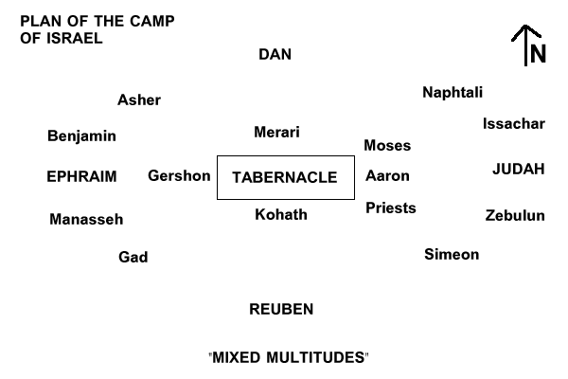

Some Other Key Events
(1) Leadership of Moses affirmed – Miriam and Aaron opposes Moses (Num 12)

(2) Authority of Aaron as High Priest affirmed – Korah’s (Levite) rebellion (Involved membes of tribe of Reuben) (Num 16-17)
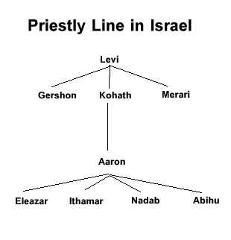
(3) Moses dishonors God at Waters of Meribah (Num 20)
(4) The Bronze Snake (Num 21)
(5) Balak and Balaam (Num 22-25)
Balak, King of Moab, tries to get Balaam to curse Israel with the offer of money.
Balaam only blesses Israel
Moab finally gets Israel cursed by seducing them into sin against God (ch 25 Particularly the tribe of Simeon) – This was by Balaam’s counsel (cf. Num 31:16; Rev 2:14). Why did Balaam do this? (2 Pet 2:15 – loved wages of wickedness; Jude 1:11 – Profit) This is perhaps the reason why God tried to kill him after telling him to go to the King of Moab (cf. Num 22:22)
(6) Two census (Num 1 and 26)
Notable are the reduction in numbers from the tribe of Reuben (46,500 to 43,730) and the tribe of Simeon (59,300 to 22,200). These are probably because Reuben’s role in Korah’s rebellion and the subsequent judgment and Simeon’s role in the seduction of Moab and the subsequent judgment.
(7) Issue with the Daughters of Zelophehad (Num 27 and 36)
(8) Succession of Moses by Joshua (Num 27)
(9) Reuben and Gad decides on land East of the Jordan (Num 32)
(10) Provisions for the tribe of Levi (Num 35) – Cities of Refuge

