God and the Land of Promise

Objectives

- Complete Session 5 – God and the Law
- Review Session 6 – God and the Land of Promise
- Time permitting, review Quick OT Survey and/or One-word summaries of OT Books

Notes

Review
Key word for Genesis: Beginnings
Key word for Exodus: Redemption

New
Key word for Leviticus: Holiness
Key word for Numbers: Wandering
Key word for Deuteronomy: Review
Key word for Joshua: Conquest
Key word for Judges: Failure

God and the Land of Promise (Deuteronomy – Judges)

Main purpose of Deuteronomy is to remind Israel of her special relationship to God. They were God’s covenant people and were to obey His laws. They were a privileged people with the responsibility to be faithful and holy. Moses’ pleas to the nation were based on several facts:
(1) God’s goodness to them in the past (4:32-40); (2) God’s goodness to them in the recent wilderness experience (29:5-9); (3) Israel’s responsibility to be a good testimony to the nations of the earth (4:6-7); (4) God’s love had been poured out on them (7:7-11); (5) God’s sure promise of blessing (7:12-14); and (6) God’s warnings of certain judgment for disobedience (29:24-28).

- The Book of Deuteronomy – Moses’ First Address (Deut 1-4) – Lessons from History (Moses Reviews Israel’s Journey from Sinai to the Plains of Moab)
Fair and equitable judgments (Deut 1:9-18)
Because of the increase in population, as God had promised (1:10), Moses was burdened with the work of administering justice for the people, so he delegated his authority to others (strange that he does not give credit to Jethro, his father-in-law for this idea). These leaders were to make judgments on smaller matters without partiality and with confidence.
The Tragedy of Lack of Faith
Moses recounts the event of the spies and the two times Israel rebelled against God, first by not taking the land and then trying to take it when God said that He would not be with them. By what things are our faith challenged today? Here are some verses that encourage faith (2 Cor 4:7-11 Jars of Clay; Ps 32 Transgressions Forgiven; Lk 12:22-32 Don’t worry; 1 Cor 10:13 No temptation)
Notice another tincture in Moses’ armor of humility. In 1:37 and 3:26, Moses blames Israel for his failure to enter the Promised Land.
God’s pronouncement of judgement comes to pass: Deut 2:14-15. Compare 1:2 to this. What at first took just 11 days, now took 38 years because of their disobedience, plus all of the first generation died, as God said would happen, because they saw the former miracles and still did not trust in God. Only Joshua and Caleb were spared.
In contrast, Deut 3:3-4 shows victory because God was both with them and gave them the victory over Og, king of Bashan.
Moses commands to obey God carefully, so as not to add or take away from God’s commands (Deut 4:1-2)
Some Key observations:
(1) Remember/Do Not Forget repeated frequently (4:9.10, 23)
(2) Warnings against idolatry (4:15-31) – Would still fail in Judges, and more in the time of the kings (4:16-1-19 with 2 KI 17:15, 16 and 4:23-24 with 2 Ki 17:18f)
(3) God has “no form” and “no form” is to be fashioned repeated: 4:12, 15, 23
(4) God’s compassion - Seek/return to God with all your heart (4:29-31)
Uniqueness of God
(1) God is incomparable (4:32)
(2) God reveals himself to his people (4:33)
(3) The Lord is the only God (4:35, 39)
(4) God redeems his people (Deut 4:37)
(5) God shows providential mercy (Deut 4:38)
(6) God offers security for the days ahead (Deut 4:39-40)

- Moses’ Second Address (Deut 5-26) – Lessons from the Law (Moses Reviews and Expands the Law for the New Generation)
The Law
Moses reviews the Law (10 Commandments in ch. 5)
Distinctions between Exodus 20 and Deuteronomy 5
Sabbath – based on deliverance from slavery in Egypt (here) vs. Creation rest in former account. This account reasons Sabbath rest for servants to rest as well.
Note: Not only not doing business but try not to go shopping, so that there might not be any kind of inducement to work.
Deut 6:4-9 Shema – “Hear” == “Listen to me!” = “Pay attention!” = “Now hear this!” (cf. Deut. 11:18ff)
(1) The LORD is one God.
(2) Love God with our whole selves.
(3) Teach God’s commands to children.
(4) Cultivate constant awareness of God’s commands.
Israel would disobey this command in the very next generation, and a whole new generation would grow up without knowing the LORD or what He had done for Israel (Jud 2:10).
Three Key Ideas (chs. 7-11)
- Destruction of Canaanites (7:1-5)
(1) Destruction was to be TOTAL and no treaties to be made (7:1-2)
(2) Intermarriage was strictly forbidden as this would lead to idolatry (7:3-4)
(3) Israel must destroy every idol (7:5)
But Israel disobeys numerous times (Jud 1:28; 2:11-12)
- Selection of Israel
(1) God’s selection (7:6)
(2) Selection not based on Israel’s size or merit (7:7)
(3) Selection based on God’s love (7:8)
- Periods of Prosperity
(1) Don’t forget God when you are prosperous (8:10-14)
(2) If you forget God, you will be destroyed (8:19)
- Blessings and Cursings
(1) Blessings if Israel carefully obeys (greater part)
(2) Cursings if Israel does not (lesser part)
Concerning the Promised Land (Deut 11:10ff) – Not as the land of Egypt that was watered by the Nile. This land could not be irrigated. The Jordan River was hundreds of feet below sea level so that it was not a source of water for crops or grazing areas. Therefore, the land was completely dependent on the rains. God promised that if Israel obeyed Him, He would always bring rain for the crops and cattle, but He would withhold rain if Israel was disobedient to His law. Drought/famine was an indicator of God’s displeasure in Israel’s disobedience (Joel 2:10-12; Hag 2:11; Jer 14:1).
Focus on God (Deut 16)
- God established a central sanctuary and commanded the destruction of pagan idols and shrines (so Israel would not be led astray by them.
- God established 3 feast days
(1) The Passover – Mar/April each year. Celebrated passing over of death angel in the final plague against Egypt.
(2) Feast of Pentacost – May/June each other. Also known as Feast of Weeks. Also known as Feast of First Fruis, as it came from first Barley Harvest
(3) Feast of Tabernacles or Booths – Oct. Also known as the Ingathering because it came at the end of the great harvest. Reenacted Israel’s journey in the wilderness. The people made booths or shelters to commemorate their ancestors’ living in tents during their wilderness wanderings.
Moses’ Third Address: The Way of Blessings and the Way of Curses (Deut 27-30) (Moses Reviews Israel’s Covenant Relationship with God)
Since the Sinai covenant was a conditional covenant, there were blessings and cursings attached to it contingent on their obedience or disobedience.
Extremely important in this section is the discussion of the Palestinian Covenant, which is the subdivision of the unconditional Abrahamic Covenant. The Palestinian Covenant gave the “title deed” of Canaan to the nation of Israel. It was and always would be Israel’s land. The borders of the land were defined in the law. However, Israel’s sin and disobedience would affect this covenant. Although disobedience would not annul the covenant, Israel could lose their right to live on the land. But it was clear that in the future, Israel would be converted and restored to the land (cf Gen 17:7-8; 13:14-17; Deut 28:63-68; 30:1-10; Lev 26:32-33; Ezek 36:24-29; 37:11-14; 34:11-31; Rom 11:26-27).
Miscellaneous Materials (Deut 31-34) – Final Ministry of Moses
Moses gave these messages on the Plains of Moab. Died at the age of 120 on Mt Nebo, where he saw the promise land but before Israel entered the Promised Land.
- The Book of Joshua
The Book of Joshua
Purpose: To record the conquest of the land of Canaan by Israel and therefore show the faithfulness of God in making Abraham “a great nation.”
Time: Covers about 30 years of Israel’s history with an emphasis on 5-7 years (based on the testimony of Caleb in Josh 14:6-11).
Key Observation: Joshua could not destroy every single Canaanite in the land in his lifetime, but he did destroy the key cities, 31 kings in all (Josh 12:24). Once the land was parceled out, it was the responsibility of each individual tribe to enter the territory and complete the job. Also, with respect to Israel’s foreign policy, Israel was not to make any treaties with nations within the boundaries of the land – these must be totally destroyed. Treaties may only be made with nations outside the boundaries of the land (cf. Ex 23:31-33; 34:11-17; Lev 18:24-25; Deut 7:1-2; 20:16-18).
Aside: Is God just in total destruction? The Scriptures and archeology show that Canaanite society had become terribly degenerate. Their perverted religious practices had so polluted them that their iniquity was as great as it could be (cf. Gen 15:16; Lev 18). They worshipped a large number of deities who were characterized by wicked behavior that in turn dictated the behavior of the Canaanites (ex. include sacred prostitution, child sacrifice and snake worship). Unger says it was the worst in the Near East at the time. Their gods were El and Baal and their goddesses were Asherah, Anath, and Astarte. These were primarily fertility gods.
- Begins Second Division of OT – History
- Joshua leads the people in Dividing and Conquering Canaan
- Outline of Joshua
(1) Taking the land (Josh 1-12)
(2) Dividing the land (Josh 12-23)
(3) Joshua’s charge (Josh 24)
The Conquest of the Land (Josh 1-12)
- Joshua’s Commission (Josh 1)
God promises victory and conquest of the land of promise. Most significantly, God says to Joshua in verse 5, “As I was with Moses, so I will be with you; I will never leave you nor forsake you.”
Repeated Charge: “Be strong and courageous”
(1) Because you are going to lead Israel to take the land
(2) Because you must be careful to obey God’s commands
(a) Be careful to obey the Law of Moses (v. 7a)
(b) Do not turn from it to the right or to the left (v. 7b)
(c) Meditate day and night on the Law of Moses (v. 8a)
(d) Then, you will be prosperous and successful (v. 8b)
(3) Because God will be with you wherever you go
- Crossing the Jordan (Josh 1:10-18)
East bank of Jordan allotted to Reuben and Gad and ½ tribe of Manasseh. These tribes raised cattle and the area east of the Jordan was better suited for their needs. But these tribes would have to help their brothers first on the other side of the Jordan.
- Spies in Jericho (Josh 2:1-24)
Two men sent to spy out Jericho. Rahab, the prostitute, hid them and protected them from the king through deception.
News about God’s supernatural help (Drying up of Red Sea; Destruction of Amorite kings Sihon and Og) to Israel reached Jericho causing great fear in the city. Rahab’s life would be saved since she helped the spies escape. (cf. Heb 11:31; James 2:23-26 – Rahab is used as an example of great faith and active faith). Rahab not only rescued them but also encouraged them saying that the people had a great fear of Israel (2:8-11). This fulfilled God’s promise in Deut 2:25 and 11:25. She was spared in battle and would later marry a prince of the tribe of Judah and become an ancestor of Jesus Christ (Num 7:12; 1 Chron 2:10-15; Matt 1:4-6)
- God’s leadership and Israel’s Obedience (Josh 3:1-5:15)
People consecrated to God
Miracle at the Jordan – God allowed Israel to cross on dry ground following the priests who carried the ark (Presence) of God ahead of them. A memorial of 12 stones (representing 12 tributes) was setup to mark the event to remind God’s people of God’s power, protection and providence.
Joshua has all the men circumcised and they celebrate Passover. At this time, the people ate unleavened cakes and the manna ceased. From the conquest onward, the people would be eating off of the fat of the land of Canaan.

- Conquest of the Land

Note: Gilgal was the base of operations for several years.
The central campaign (6:1-9:27)
Jericho marks the start of the central campaign. Jericho symbolized the strength of Canaan. It was well fortified and strategically located. By taking Jericho, Joshua effectively divided Canaan in half. In the Jericho account, it is clear that the LORD fought for Israel. Notable, in the conquest of Jericho was that none of the loot was to be taken but put in the Lord’s treasury because he won the victory for them. Also, everyone was killed except Rahab and her family.
The conquest of Canaan followed a course that in retrospect appears as though it had been planned by a brilliant strategist. Taking Jericho gave Israel control of its strategic plains, fords and roads as a base of operations. When Israel next gained control of the Bethel, Gibeon and Upper Beth Horon region, it dominated the center of the north-south Palestinian ridge. Subsequently, Israel was able to break the power of the allied urban centers in separate campaigns south and north.
Ai – An unbelievable defeat followed the unbelievable victory over Jericho. Ai only had 3000, though they fought bravely. They lost because of the sin of one man in Israel, Achan, who kept some of the spoils of war for himself against the Lord’s clear command (6:17-19,24). Once the sin was purged, Joshua was able to take Ai and Bethel.
The destruction of both Jericho and Ai led to a major victory against the Canaanites in the Valley of Aijalon – the “battle of the long day” – which then allowed Joshua to proceed against the cities of the western foothills.
Archeological evidence for the conquest is mixed, in part because the chronological problems are unsolved. On the one hand, clay tablets containing cuneiform letters to the Egyptian court have been found at Fell el-Amarna in Egypt from c.1375 B.C. These mention bands of Habiru who threaten many of the cities of Canaan and create fear among the Canaanite inhabitants.
Note: Sin among God’s people can affect all believers.
Joshua’s mistake – fell for Gibeonite deception – he did not consult the Lord (Josh 9:14). So Joshua violated God’s command not to make treaties with nations within the boundaries of the promised land.
Note: The importance of consulting the Lord first in all things

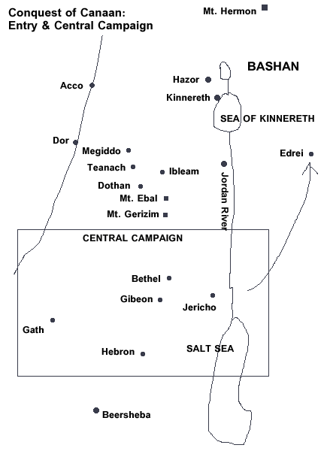

The southern campaign (Josh 10:1-43)
The southern campaign began when Adoni-Zedek, the king of Jerusalem, called four other kings to join him in attacking Gibeon. Gibeon appealed to Joshua for help and Israel defended them because of the covenant they had been tricked into making.
Joshua won because the LORD routed the enemy (Josh 10:10) but the victory was incomplete and would be so until the time of King David. The LORD also caused the sun to stand still so that Joshua could inflict greater destruction on his enemies.
Lachish, Debir, Libnah, Eglon and Makkedah ( a town near Beth Shemesh and Azekah, whose exact location is unkown) were all captured by Joshua in his attack on the lowland foothills controlling the approaches to the Judahite plateau. Several of these towns, most notably Lachish, contain destruction evidence that might possibly be correlated with the Israelite conquest.
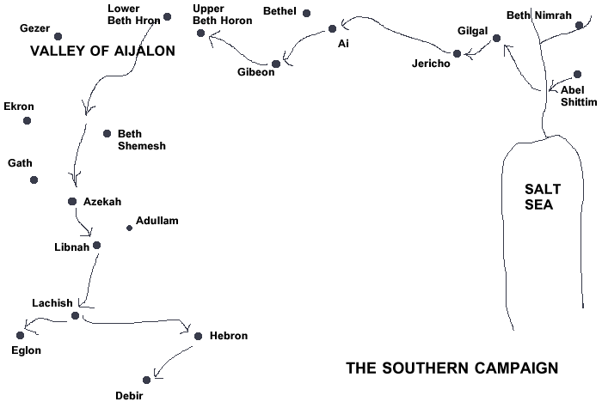

The northern campaign (Josh 11:1-12:24)
Jabin, the king of Hazor, the only fortified city taken in this campaign. The LORD gave them into Israel’s hands.
Certain areas not taken by Joshua were built on mounds called “tells.” These cities were built on high places and made for difficult conquest. Joshua had much left to conquer as he was getting ready to die (Joshua 13:1; cf 11:16 and 13:7 for the list of conquered and unconquered lands).
Late Bronze Age Hazor was burned by Joshua (Jos 11:13). Excavations have revealed three clearly datable destruction layers, one of which may provide the strongest evidence yet for a historically verifiable date for the conquest. The excavator thought Joshua burned the latest level (c. 1230 BC), but others argue that it must actually have been the earliest of the three levels, c. 1400 BC.
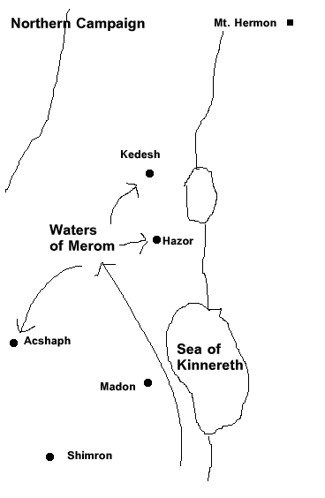

The Division of the Land (Josh 13:8-23:16)
Josh 13-23 describes the actual division of the land of Canaan. All Israel gather at Shiloh (Josh 18:1).
Josh 20 describes the cities of refuge for those who kill another unintentionally to flee to from those who might kill them out of revenge. There were three on the west side of the Jordan and three on the east side. They would be required to stay there until he is tried and then until the death of the high priest of the city.
Joshua’s Charge (Josh 24)
One of Joshua’s last acts was to challenge the Israelites to be faithful to God. Joshua’s charge is divided into three parts:
(1) The basis of his charge: What the Lord has done for Israel (vv 1-13)
(2) The charge: Fear God and serve Him (vv 14-23)
(3) The renewal of the covenant (vv 24-28)
Key verse: Joshua 24:15 “But if serving the LORD seems undesirable to you, then choose for yourselves this day whom you will serve, whether the gods your forefathers served beyond the River, or the gods of the Amorites, in whose land you are living. But as for me and my household, we will serve the LORD.”
- The Book of Judges
The Judges
Observations
Dating – difficult but took place sometime between the conquest of Canaan (1400-1200 BC) and the destruction of Shiloh (about 1050 BC).
Judges were probably not national leaders but regional deliverers. This period was what might be termed a Theocracy, where God was king.
Key Background Scriptures:
Deut 7:1-4 Here God provides commands to preclude the slide into depravity by Israel
Ps 106:34-39 Commentary on Judges with respect to the extent of Israel’s sins
Josh 24: 29-31 Shows how quickly Israel fell away from the Lord after Joshua’s death
It is unclear whether the accounts of the judges are in chronological order. Some may have served Israel at or about the same time though perhaps serving different regions.
Major (more biblical space) and minor judges (less biblical space):
Major Judges (Years Judged) | Minor Judges (Years Judged)
3:7-11 Othniel defeats Aram Naharim (40) | 3:31 Shamgar (unkown)
3:12-30 Ehud defeats Moab (80) | 10:1-2 Tola (23)
4:1-5:31 Deborah defeats Canaan (40) | 10:3-5 Jair (22)
6:1-8:28 Gideon defeats Midian (40) | 12:8-10 Ibzan (7)
10:6-12:7 Jephthah defeats Ammon (6) | 12:11-12 Elon (10)
13:1-16:31 Samson checks Philistia (20) | 12:13-15 Abdon (8)

A Four-Phase Cycle
(Judges 2:11-19 expresses this four-phase cycle)
First: People rebelled against the Lord
Second: God punished the people by delivering them into the hands of evil oppressors.
Third: The people of Israel cried out to the Lord for deliverance.
Fourth: God raised up a judge to deliver the people of Israel from their oppressors.
- Othniel (3:7-11) – Othniel delivered Israel from the hand of the king of Mesopotamia. Othniel was Caleb’s younger brother. He delivered the people of Israel when the Spirit of the Lord came on him.
- Ehud (3:12-30) – Ehud, a Benjaminite, delivered the people of Israel from Eglon, the king of Moab, who had dominated them for 18 years. Judges 3:12 is a typical reference showing the people’s rebellion and God’s punishment for their sins: “Once again the Israelites did evil in the eyes of the Lord, and because they did this evil the Lord gave Eglon king of Moab power over Israel.”
- Deborah (4:1-5:31) – Deborah and her army commander Barak delivered the people of Israel from Jabin, king of Canaan, and his army commander, Sisera. Deborah selected Barak from the tribe of Naphtali to lead the army of Israel against Sisera. This military action was the closest that any of the judges came to a national movement of the tribes. God used Deborah herself to defeat Sisera. Judges 5 is poetry.
- Gideon (6:1-8:28) – Gideon delivered the people of Israel from the hand of the Midianites. When God chose him, Gideon protested his inability to lead the people of Israel. God have Gideon a sign to counteract his weakness. Possibly because of Gideon’s weakness and lack of faith, God told Gideon to release most of the troops to go home. God used a small army of 300 men to defeat the Midianites. The story of Gideon illustrates the power of God and the importance of faithfulness. Israel wanted Gideon to be their king, but Gideon refused. His reply was that only the Lord is king. In Judges 8:23, Gideon responded to their request by saying, “I will not rule over you, nor will my son rule over you. The Lord will rule over you.”
- Jephthah (10:6-12:7) – Jephthah, a Gileadite, is best known for having delivered the people of Israel from the power of the Ammonites. He also is known for the foolish, unnecessary vow he made. He vowed to the Lord that if He would grant him victory over the Ammonites, he would offer whatever would come forth first from his house to the Lord. Sadly, Jephthah’s daughter rushed out to greet him at his victory. Later, Jephthah sacrificed his daughter because of his vow.
- Samson (13:1-16:31) – The end of the Book of Judges may be describing how Samson had failed as a judge. He judged Israel and saved the nation from the oppression of the Philistines. He was a man of little character and few principles. Samson possessed enormous potential, but he used his opportunities unwisely. God gave Samson the responsibility to lead the nation, but Samson failed.
Lack of Sound Leadership (Judg 17-21)
Judges 17-21 describes how people lived when they had little leadership or when they had poor leadership. The end of the Book of Judges may be describing how Samson had failed as a judge. Or, it may be an attempt to justify the need for a king. References to the lack of a king appear three times (Judg 18:1; 19:1; 21:25). Whatever the purpose of these chapters, they record some of the most sordid events found anywhere in the Bible.

